### TITLE

**A**

**Project Report**

**On**

A STUDY ON CUSTOMER SATISFACTION TOWARDS MARUTI SUZUKI CARS IN SURAT CITY

**A Report Submitted to**

SDJ International College, Vesu

**Affiliated to: Veer Narmad South Gujarat University, Surat**

For,

Partial requirement for the fulfilment of the Degree of

Bachelor of Business Administration (BBA)

**Submitted by:**

**MODI DEV BHAVESHKUMAR**

Roll No.: 123

SPID: 2021052001

**Under the Guidance of**

**Dr. Darshana Shah**

*SDJ International College,*

*(BBA PROGRAMME)*

**April 2024**

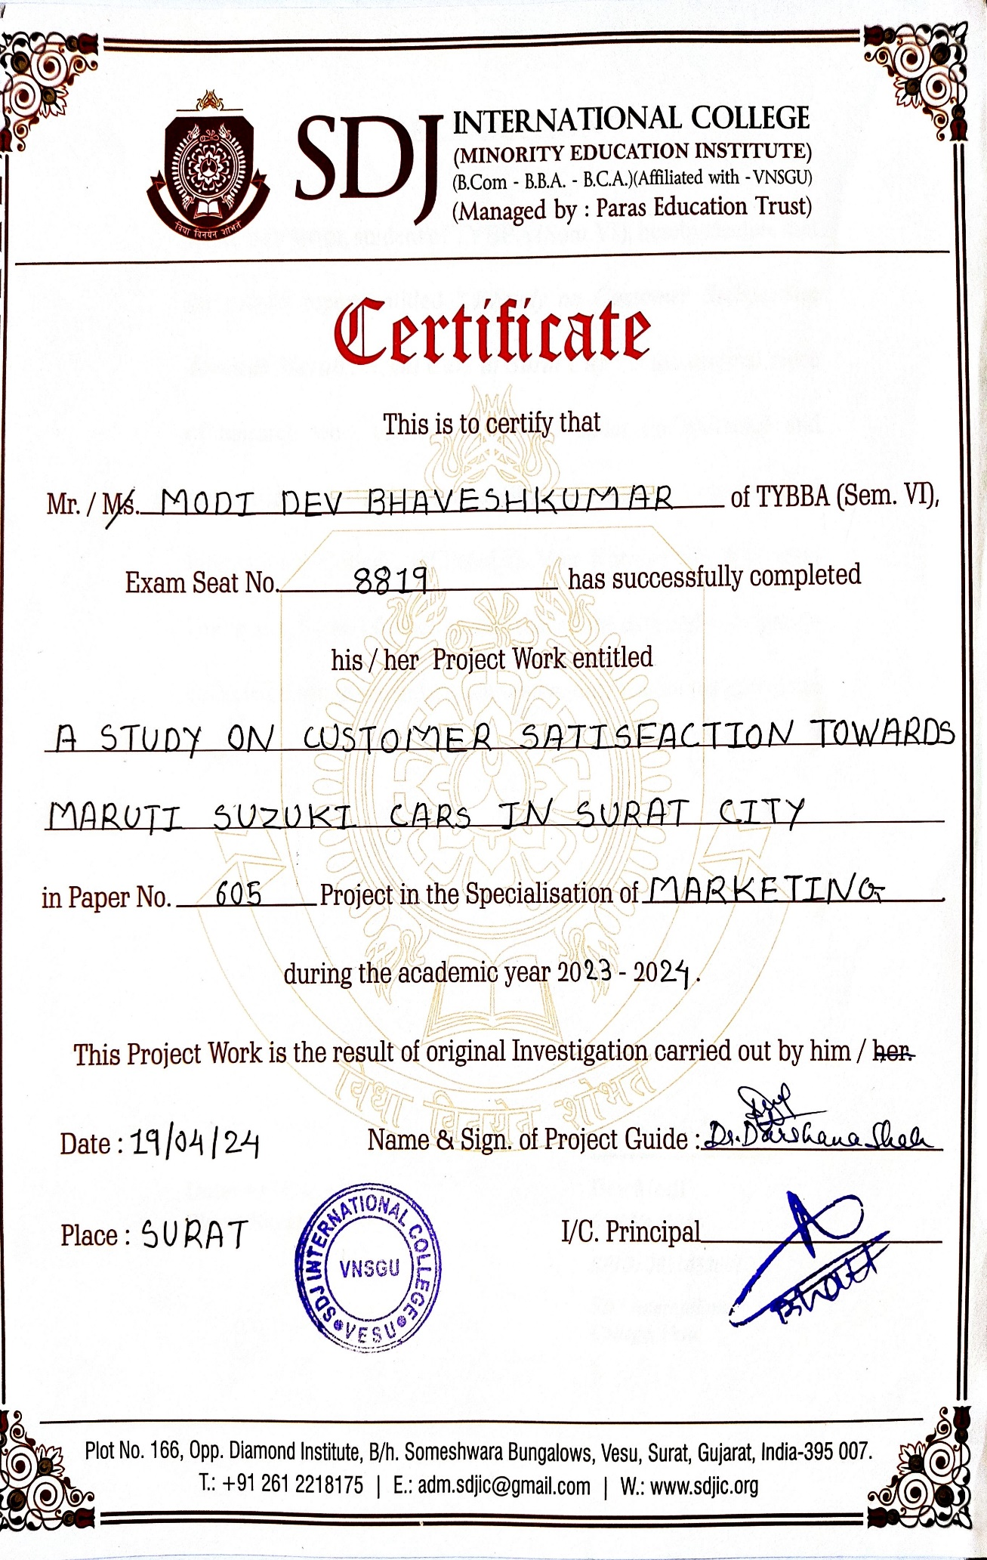COLLEGE CERTIFICATE

DECLARATION

I, **MR**. **DEV MODI**, student of TYBBA (Sem.VI), hereby declare that the project report entitled ***“A Study on Customer Satisfaction Towards Maruti Suzuki Cars in Surat City”*** is the original piece of research work carried out by me under the guidance and supervision of **Dr. Darshana Shah** Assistant Professor, SDJ International College, affiliated to Veer Narmad South Gujarat University, Surat. I further declare that all the data and information collected through secondary sources are duly acknowledged in the report.

-------------------

Date: Dev Modi

**Place: Surat *Roll No.:123***

***SPID: 2021052001***

***SDJ International College, Vesu***

ACKNOWLEDGEMENTS

At this point, when I am about to finish my project work, it is my privileged opportunity to thank all those people for their contribution provided to this research work.

Firstly, I wish my heartfelt thanks to in-charge principal of this college Dr. Aditi Bhatt, who always motivate us to fulfill our dreams and lead us in the direction of growth. She has given her valuable inputs for effective completion of this project.

Next, I would like to thank our IQAC Coordinator, Dr. Vaibhav Desai, who always work and think in the direction of betterment of the students and institute as well as supporting us with all the necessary resources to finish our three golden years of graduation.

I cannot forget the contribution of my project guide Dr. Darshana Shah, without the support of whom I would have never completed this report. Her constant help, guidance and continuous teaching has given me so many inputs on academic as well as non-academic front.

I also would like to thank Prof. Sneha Rajesh Saraf for coordinating Winter Internship Project in the right direction.

I would also like to thank **Ms. Kinjal Patel, Librarian,** with the effort of whom, we could get the insights and learning from past years reports.

Lastly, I would thank all my friends, respondents and other persons directly or indirectly, who have supported me in completing this report.

April, 2024 Dev Modi

Surat

TABLE OF CONTENTS

TITLE I

COLLEGE CERTIFICATE II

DECLARATION III

ACKNOWLEDGEMENTS IV

CHAPTER 1: INTRODUCTION 1

1.1 CUSTOMER SATISFACTION 1

1.2 INDUSTRY PROFILE 2

1.3 COMPANY PROFILE 4

1.4 VISION 11

1.5 MISSION 11

1.6 SWOT ANALYSIS 11

1.7 OTHER OBJECTIVES OF MARUTI SUZUKI 12

1.8 MARKETING STRATEGY 12

CHAPTER 2: REVIEW OF LITRETURE 15

CHAPTER 3: RESEARCH METHODOLOGY 26

3.1 ABOUT THE RESEARCH 27

3.2 RESEARCH OBJECTIVE 28

3.3 VARIABLES OF THE STUDY 28

3.4 RESEARCH DESIGN 30

3.5 DATA COLLECTION 31

3.6 SAMPALING DESIGN 31

3.7 DATA PROCESSING 32

3.8 LIMITATIONS OF THE REPORT 32

3.9 CHAPTERISATION OF THE REPORT 32

CHAPTER 4: DATA ANALYSIS AND INTERPRETATION 33

4.1 AGE 33

4.2 GENDER 34

4.3 OCCUPATION 35

4.4 ANNUAL FAMILY INCOME 36

4.5 HAVE A MARUTI SUZUKI CAR 37

4.6 MODEL OF MARUTI SUZUKI CAR YOU OWN 38

4.7 MOST FAVOURITE COLOUR IN MARUTI SUZUKI CAR 39

4.8 VARIANT YOU LIKE TO PURCHASE MARUTI SUZUKI CAR 40

4.9 MEDIA TOOL THAT INFLUENCED TO BUY MARUTI SUZUKI CAR 41

4.10 OPINION ABOUT PRICE OF MARUTI SUZUKI CAR 43

4.11 TIME PERIOD OF USING MARUTI SUZUKI CAR 44

4.12 FIRST PREFERENCE TO MARUTI SUZUKI WHILE BUYING CAR 45

4.13 OPINION ABOUT SERVICE OF MARUTI SUZUKI WITH OTHER COMPANY 46

4.14 FEATURE OF MARUTI SUZUKI CAR 47

4.15 OVERALL OPINION ABOUT MARUTI SUZUKI CAR 48

4.16 EXPECTING CHANGES IN MARUTI SUZUKI CAR 49

4.17 FULL-SIZE SUV CAR SEGMENT WILL IMPROVE SALES OF MARUTI SUZUKI CAR 50

4.18 MARUTI SUZUKI IN TERM OF RELIABILITY AND TRUSTWORTHINESS 51

4.19 CONSIDER A MARUTI SUZUKI CAR FOR NEXT PURCHASE 53

4.20 FACTOR INFLUENCED TO CHOOSE A MARUTI SUZUKI CAR 54

4.21 OVERALL PERFORMANCE OF MARUTI SUZUKI CAR 55

4.22 SATISFACTION OF AFTER-SALES SERVICE 56

4.23 RECOMMEND MARUTI SUZUKI TO FRIENDS OR FAMILY 58

4.24 REASONS FOR NOT CHOOSING MARUTI SUZUKI CAR 59

4.25 HAVE A MARUTI SUZUKI CAR & MARUTI SUZUKI CAR MODEL OWN 60

4.26 TIME PERIOD OF USING MARUTI SUZUKI CAR & OVERALL OPINION ABOUT MARUTI SUZUKI CAR 62

4.27 MODEL OWN & FUEL TYPE 64

4.28 PRICE OPINION & MARUTI SUZUKI MODEL OWN 65

CHAPTER 5: FINDINGS AND CONCLUSION 66

5.1 GENERAL FINDINGS 66

5.2 MAJOR FINDINGS 67

5.3 CONCLUSION 70

5.4 RECOMMENDATION 70

BIBLIOGRAPHY 71

ANNEXURE-1 75

ANNEXURE-2 79

**LIST OF TABLES**

Table 4.1 Age 33

Table 4.2 Gender 34

Table 4.3 Occupation 35

Table 4.4 Annual Family Income 36

Table 4.5 Have a Maruti Suzuki Car 37

Table 4.6 Model Own 38

Table 4.7 Most Favourite Colour 39

Table 4.8 Fuel Type 40

Table 4.9 Media Tools 41

Table 4.10 Price Opinion 43

Table 4.11 How Long Use Car 44

Table 4.12 First Preference 45

Table 4.13 Service Opinion 46

Table 4.14 Feature 47

Table 4.15 Overall Opinion 48

Table 4.16 Expecting Changes 49

Table 4.17 Full-Size SUV Segment 50

Table 4.18 Reliability & Trustworthiness 51

Table 4.19 Next Purchase 53

Table 4.20 Factor Influenced 54

Table 4.21 Overall Performance 55

Table 4.22 After-Sales Service 56

Table 4.23 Recommend 58

Table 4.24 Reasons for not Choosing 59

Table 4.25 Have a Maruti Suzuki Car & Maruti Suzuki Car Own 60

Table 4.26 Time Period of Using Maruti Suzuki Car & Overall Opinion about Maruti Suzuki Car 62

Table 4.27 Model Own & Fuel Type 64

Table 4.28 Price Opinion & Maruti Suzuki Model Own 65

**LIST OF FIGURES**

Figure 4.1 Age 33

Figure 4.2 Gender 34

Figure 4.3 Occupation 35

Figure 4.4 Annual Family Income 36

Figure 4.5 Have a Maruti Suzuki Car 37

Figure 4.6 Model Own 38

Figure 4.7 Most Favourite Colour 39

Figure 4.8 Fuel Type 40

Figure 4.9 Media Tools 41

Figure 4.10 Price Opinion 43

Figure 4.11 How Long Use Car 44

Figure 4.12 First Preference 45

Figure 4.13 Service Opinion 46

Figure 4.14 Feature 47

Figure 4.15 Overall Opinion 48

Figure 4.16 Expected Changes 49

Figure 4.17 Full-Size SUV Segment 50

Figure 4.18 Reliability and Trustworthiness 51

Figure 4.19 Next Purchase 53

Figure 4.20 Factor Influenced 54

Figure 4.21 Overall Performance 55

Figure 4.22 After-Sales Service 56

Figure 4.23 Recommend 58

Figure 4.24 Reasons for not Choosing 59

Figure 4.25 Have a Maruti Suzuki Car & Maruti Suzuki Car Model Own 60

Figure 4. 26 Time Period of Using Maruti Suzuki Car & Overall Opinion About Maruti Suzuki Car 62

Figure 4.27 Model Own & Fuel Type 64

Figure 4.28 Price Opinion & Maruti Suzuki Model Own 65

CHAPETER 1

INTRODUCTION

# CHAPTER 1: INTRODUCTION

1. CUSTOMER SATISFACTION

In simple words, customer satisfaction is a measurement that determines how well a company’s products or services meet customer expectations. It’s one of the most important indicators of purchase intentions and customer loyalty. As such, it helps predict business growth and revenue.



Customer is term where we use in our daily life. And satisfaction means fulfil one’s wishes and expectations the Whole words lots of marketing agency and era of marketing mainly focuses on this thing. customer satisfaction is a key performance indicator in the area of marketing. And it is a prospective balance scorecard. In a market where is competition is getting high and high Customer Satisfaction is key where we can use as a main vision and differentiate the product and with the effect of this the company growing rapidly in all the aspects of the business. It is a key factor and it’s driven successfully in the private sectors many organizations use this strategy and growing rapidly. Many of the High-profile organization using ideas for giving the better customer Satisfaction. A framework is set to be and also principles set for the customer satisfaction. Customer satisfaction empower the individuals. Customer satisfaction Is measured how Products and service meet to the customer’s requirements through the customer satisfaction we can analyze what type of trend going in the market and the according to that organization creating a product that can meets the customer demand and increasing the profits.

The concept of customer satisfaction is a central position in a market though practises. Satisfaction is major outcome of marketing activity and serves as the greater advantage of the organization.

1. INDUSTRY PROFILE
2. **AUTOMOBILE INDUSTRY**

The Indian automobile industry has historically been a good indicator of how well the economy is doing, as the automobile sector plays a key role in both macroeconomic expansion and technological advancement. The two-wheelers segment dominates the market in terms of volume, owing to a growing middle class and a huge percentage of India’s population being young. Moreover, the growing interest of companies in exploring the rural markets further aided the growth of the sector. The rising logistics and passenger transportation industries are driving up demand for commercial vehicles. Future market growth is anticipated to be fuelled by new trends including the electrification of vehicles, particularly three-wheelers and small passenger automobiles.

India enjoys a strong position in the global heavy vehicles market as it is the largest tractor producer, second-largest bus manufacturer, and third-largest heavy truck manufacturer in the world. India’s annual production of automobiles in FY22 was 22.93 million vehicles. India has a strong market in terms of domestic demand and exports. In FY23, total passenger vehicle sales reached 3.89 million. In FY23, total automobile exports from India stood at 47,61,487. This sector's share of the national GDP increased from 2.77% in 1992-1993 to around 7.1% presently. It employs about 19 million people directly and indirectly.

India is also a prominent auto exporter and has strong export growth expectations for the near future. In addition, several initiatives by the Government of India such as the Automotive Mission Plan 2026, scrappage policy, and production-linked incentive scheme in the Indian market are expected to make India one of the global leaders in the two-wheeler and four-wheeler market by 2022.

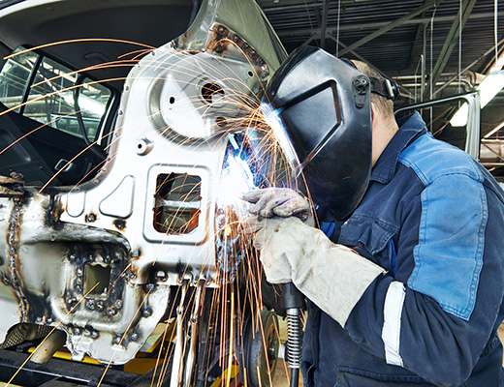

1. **MARKET SIZE**

The Indian passenger car market was valued at US$ 32.70 billion in 2021, and it is expected to reach a value of US$ 54.84 billion by 2027 while registering a CAGR of over 9% between 2022-27. The global EV market was estimated at approximately US$ 250 billion in 2021 and by 2028, it is projected to grow by 5 times to US$ 1,318 billion.

In July 2023, the total production of passenger vehicles, three wheelers, two wheelers, and quadricycles was 2.08 units.

In the first quarter of 2023-24, total production of passenger vehicles, commercial vehicles, three wheelers, two wheelers, and quadricycles was 6.01 million units.

India accomplished a significant milestone, with the sale of 8,32,434 EVs in 2023-24 (till August 2023).

The electric vehicle (EV) market is estimated to reach Rs. 50,000 crore (US$ 7.09 billion) in India by 2025.A study by CEEW Centre for Energy Finance recognised a US$ 206 billion opportunity for electric vehicles in India by 2030. This will necessitate a US$ 180 billion investment in vehicle manufacturing and charging infrastructure.

According to NITI Aayog and the Rocky Mountain Institute (RMI), India's EV finance industry is likely to reach Rs. 3.7 lakh crore (US$ 50 billion) by 2030. A report by the India Energy Storage Alliance estimated that the EV market in India is likely to increase at a CAGR of 36% until 2026. In addition, the projection for the EV battery market is expected to expand at a CAGR of 30% during the same period.

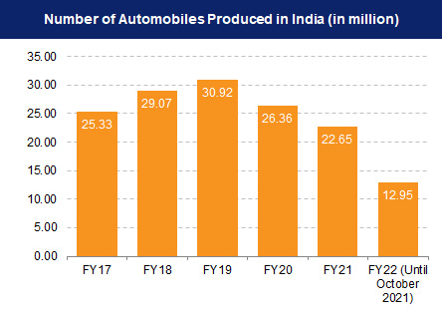

Indian automotive industry is targeting to increase the export of vehicles by five times during 2016-26. In FY23, total automobile exports from India stood at 47,61,487. Indian automobile exports of two-wheelers stood at 36,52,122 in FY23.

1. COMPANY PROFILE
2. **MARUTI SUZUKI INDIA LTD.**

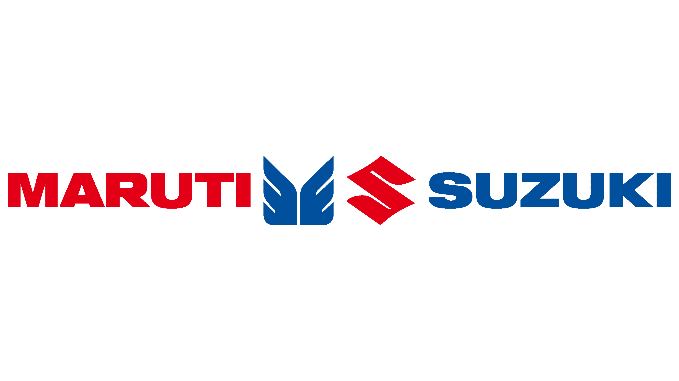

Maruti Suzuki India Limited, formerly known as Maruti Udyog Limited, is an Indian automobile manufacturing company, founded by Government of India in 1981, headquartered in New Delhi, India. On October 1982 the company merged with Suzuki Motor Corporation a Japanese automobile company. Maruti Suzuki is a 56.21% owned subsidiary of Suzuki Motor Corp. R.C. Bhargava is the Chairman and Kenichi Ayukawa is the Managing Director & CEO of the company. As of July 2018, it had a market share of 53% in the Indian passenger car market.

This chapter consists of overview of Maruti Suzuki India Limited with respect to Manufacturing facilities, Corporate Milestones. Sales and Service network with their few popular brands History & Milestone of Maruti Suzuki India Limited Maruti Suzuki is one of the leading automobile manufacturing companies in India. It is the market leader in the automobile industry both in terms of production and revenue generation. The history of Maruti Suzuki is very fascinating. In the year February 1981, Maruti Udyog Limited was incorporated under the provisions of the Indian companies act, 1956. The major objectives of Maruti Udyog were to modernize the Indian automobile industry, to produce fuel-efficient cars and mass number of vehicles. The company was formed as a government company, with Suzuki as a minor partner, to make people's car for middle class India. In October 2, 1982, the company signed the license and joint venture agreement with Suzuki Motor Corporation of Japan. In the year 1983, the company started their productions and launched Maruti 800.

In the year 1983, the company launched its most awaited Maruti Omni and in 1985, the company launched Maruti Gypsy in the Indian Market. The Gypsy was the first modern four-wheel drive vehicle in the Indian market. In June 1986, the company launched new model of Maruti800.

In the year 1987, the company forayed into the foreign market by exporting first lot of 500 cars to Hungary. In the year 1990, the company launched India's first three box car, sedan 1.e Maruti 1000. In the year 1992, Suzuki Motor Corporation. Japan increased their stake in the company to 50 percent. In the year 1993, the company introduced the Maruti Zen and in 1994 the company launched Maruti Esteem in the market. In the year 1995, the company commenced their second plant. In the year 1997, the company started Maruti Service Master as model workshop in India to look after sales services. In the year 1999, the third plant with new press, paint and assembly shops became operational. With the growing demand of customers in the Indian automobile market the company launched Maruti Alto in 2000.

1. **HISTORY**

* **1981 – Maruti Udyog Ltd**

India was regaining the glory after independence. People started to look out for ways to live an elegant life. But no one was spending a lot on cars. Brands like Premier and Hindustan Motors were trying hard to gain customers to which they were a lot successful. But were they ready for the storm that was about to come?

Government of India, especially, Sanjay Gandhi is to be credited with the establishment of Maruti Udyog Limited in 1981.

* 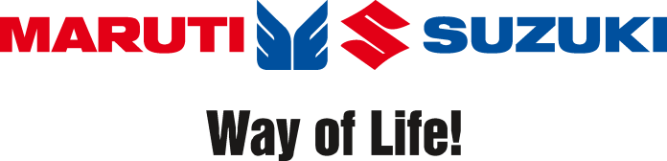**1982 – Collaboration with Suzuki**

In October 1982, Maruti Udyog limited merged with the Japanese automobile company, Suzuki. The same year, the company also set up a manufacturing unit at Gurgaon, Haryana. With the JV between Maruti and Suzuki, the company received the right to import 40,000 fully built Suzuki cars from Japan in the first two years, after which also the company was planning to use about 33% of indigenous products only.

* **1983 – Maruti 800**

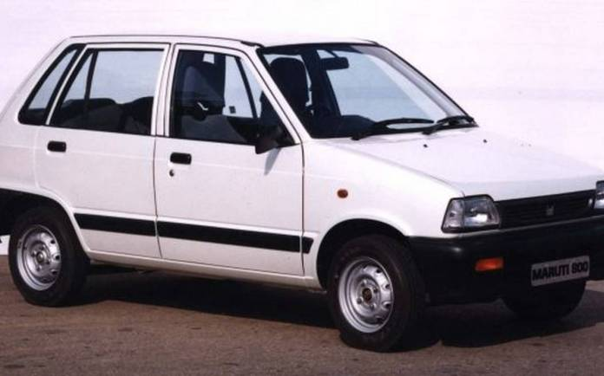

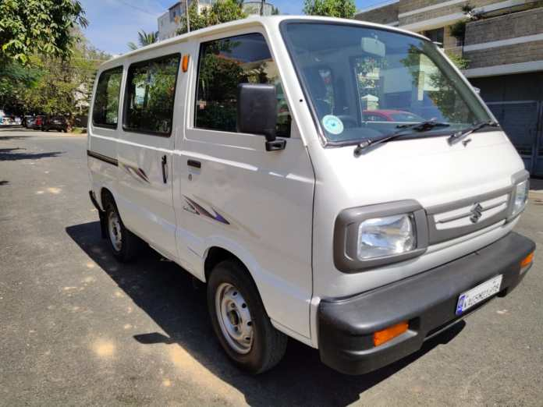This is the car which flagged off the company’s dawn was the Maruti 800. It was an 800cc engine powered 5-door hatchback made by Maruti Suzuki which instantly became a hit in the market. 800 was so popular that if in the mid-1980s, someone was talking about Maruti, he surely was talking about the 800. It became the acronym for the company. But Maruti 800 was not the only car to be launched that year.

Every child’s fear, the kidnapping car of that era, Maruti Omni was also launched at that time powered by the same engine as that of the 800.

* **1985 – The Off-roading King Launched**

There’s no doubt that even without the mention of the car, you would have guessed the name. Maruti Suzuki Gypsy was launched in 1985. A 4WD off-roading vehicle was launched and instantly became a hit, especially in the off-roading arena. It was based on the Suzuki Jimny and was powered by a 1.0-litre engine.

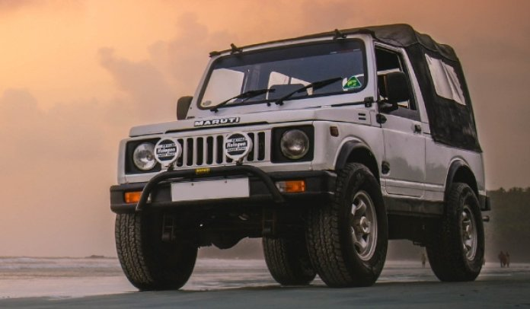

* **1986 – Maruti Suzuki reaches a milestone**

1,00,000th vehicle rolled out the factory of the company. Within 2 years, Maruti Suzuki was dominating the market. The same year, the company also launched a new generation of 800, which was the SS80 Alto hatchback known globally. In 1987, the company exported 500 cars to Hungary thus commencing the sales outside India, via export.

* **1989 – India’s first sedan launched**

Maruti 1000, launched in 1989, was India’s first sedan which was powered by a 1.0-litre engine. It became a huge success due to its off-roading capabilities, though was not that popular as a family car.

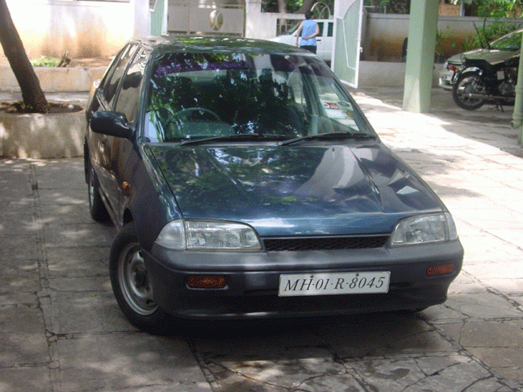Then in the next few years, Maruti Suzuki launched many cars. Here is the list of cars with the year they were launched in.

* Maruti Suzuki Zen – 1993
* Maruti Suzuki Esteem – 1994
* Wagon R and Baleno Sedan – 1999
* Alto – 2001

By the year 1994, Maruti Suzuki had sold 1 million cars in India. Maruti also opened a second plant which increased the annual capacity of the company from 1,00,000 to 2,00,000 units.

* **1998 – Company’s first diesel car**

Zen D or the Zen Diesel was Maruti’s first diesel offering in India. It was powered by a 1.5-litre diesel engine.

* **2004 – Alto overtakes 800**

Maruti Suzuki Alto became the highest selling car in India overtaking 800 after nearly two decades of ruling the arena. Alto stayed at the top for a straight 15 years after that, only to be dethroned by the Maruti Suzuki Dzire in 2019.

* 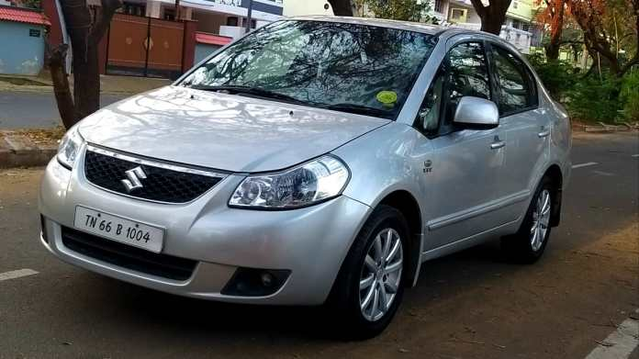**2007 – Maruti Suzuki SX4 launched**

The premium looks and the stylish interiors made it an instant success story. SX4 had an amazing ride quality. It was powered by a 1.6-litre VVT DOHC petrol engine which could churn out 104hp of power and 145Nm of torque. But with the advent of diesel engines in the segment, SX4 started losing the monopoly in the market. In 2011, Maruti Suzuki tried to revive the SX4 by introducing a 1.3-litre diesel engine which could produce 88hp of power and a torque of 200Nm. But by the time SX4 got this oil burner, it was too late. The sedan was discontinued in 2014. You might easily see one running on the roads at present.

* 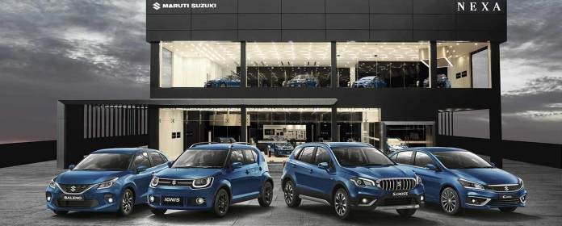**2015 – NEXA**

New Exclusive Automotive Experience or the NEXA platform was introduced by the company to launch premium cars in India. The first car to be sold through this channel was the S-Cross. Maruti Suzuki sells Baleno, XL-6, Ciaz and Ignis currently through this channel. S-Cross petrol is to be launched soon. Introducing a brand for premium cars was a wise choice as the company failed to attract customers through the normal channel. Would the premium luxury cars have been sold as the same fate as that of the Kizashi and other premium cars.

* **2016 – Company’s first compact SUV**

Maruti Suzuki’s first-ever compact SUV was unveiled at the Auto Expo 2016. The car carried forward the name from the Grand Vitara and added a light wind to it, thus Vitara Brezza.

How the Maruti Vitara Brezza Changed the Compact SUV Category in India.

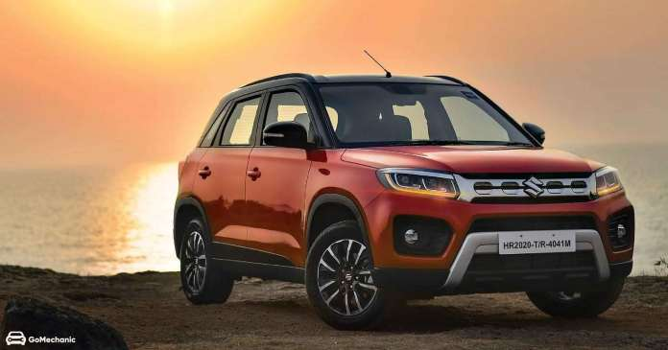

Initially, it was offered 1.3-Litre D13A four-cylinder turbodiesel engine which could produce 89hp of power and a peak torque of 200Nm. The mill is mated to a 5-speed manual gearbox. With the ARAI certified range of 24.3kmpl. Vitara Brezza became the best-in-segment car for the mileage. And this was enough for the buyers to select it over the rivals. The starting price of ₹6.99lakhs just acted as the fuel for skyrocketing sales of the SUV.

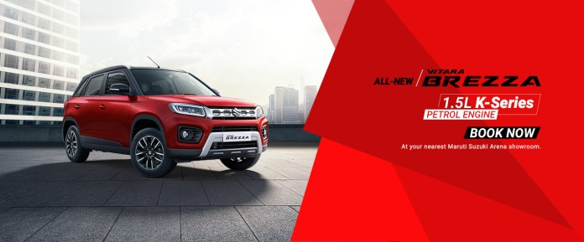

The SUV became a hit as there was no direct competition in the arena. It recently was given a new facelift in 2020.

* **2020 – The BS6 Effect**

With the BS6 emission norms taking place of the previous BS4 norms, the company had to discontinue all the diesel variants across its offerings. Thus, all the cars across the line-up are currently being offered with petrol engine options only with CNG options too.

There seems to be no end to the popularity of the company although the safety of most of the cars from the manufacturer is questionable. A very few of its offerings were able to score over 3 stars at any NCAP. Is this how the company keeps the cost down, by keeping the safety at risk? What do you think about the question? Let us know in the comments section below.

1. VISION

The Leader in the Indian Automobile Industry, Creating Customer Delight and Shareholder's Wealth; eventually become a pride of India”.

1. MISSION

* Modernization of the Indian Automobile Industry.
* Developing cars faster and selling them for less.
* Production of fuel-efficient vehicles to conserve scarce resources.
* Production of large number of motor vehicles which was necessary for economic growth.
* Market Penetration, Market Development Similarly Product Development, and Diversification.
* Partner relationship management, Value chain, Value delivery network.

1. SWOT ANALYSIS

* **Strengths**
* Continuously increasing overall performance and strong equity in the market.
* Expanded product offerings and history of launching almost all the car successfully.
* NEXA and ARENA are at top of high customer score of satisfaction.
* Very healthy balance sheet and improving bottom line and share value.
* **Weakness**
* Cockpit quality, dashboard material and look to be improved which is still lacking than the competition.
* Maruti cannot command premium because of its middle income and affordable imaginary.
* **Opportunities**
* Surge in economic level of the consumers
* **Threats**
* In between step of demonetisation taken by government has pulled down the national economy & no cash transaction beyond 2 lakhs INR
* Other MNC also putting up plants in India.

1. OTHER OBJECTIVES OF MARUTI SUZUKI

* To uphold and fuel the historical growth of Maruti Suzuki in India.
* To revive the progress of Indian automobile sector.
* To understand the marketing strategies of Maruti in India, and to use it to the fullest potential.
* Production of fuel-efficient vehicles to conserve the limited fuel resources.
* To create a “WOW” factor in each car it produces.
* To have defined cars for various market segments like premium segment, budget segment, etc.
* To be always a leading manufacturer in the Indian car market.
* To become the most preferred car brand of the Indian customers.
* To provide a comfortable, stylish, and high-performance car in the desired price range for the target audience.

1. MARKETING STRATEGY

* **MARKETING MIX**
* Combination of factors that can be controlled by a company to influence consumers to purchase its products is commonly called as Marketing Mix. It is a set of marketing tools that the firm uses to pursue its marketing objectives in the target market. Thus, the marketing-mix refers to four broad levels of marketing decisions namely – product, price, place, and promotion.
* **PRODUCT MIX:**
* Maruti Suzuki India Limited have 53% market share in the Indian market. All the products of Maruti Suzuki India Limited are made keeping the common man in mind. Means the product quality is suited for every segment of the population either it is urban or rural. It manufactures different types of cars and sells them in the market.

|  |  |
| --- | --- |
| NEXA | ARENA |
| GRAND VITARA | **ALTO** |
| IGNIS | **ALTO** |
| XL-6 | **WAGONR** |
| BALENO | **BREZZA** |
| CIAZ | **CELRIO** |
| FRONX | **ECCO** |
| JIMMY | **ERTIGA** |
|  | **S.PRESSO** |
|  | **DZIRE** |

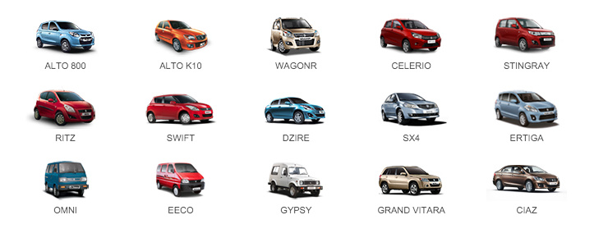

* Features of these cars known for their durability, service, car design and most things which we expect from a basic car. The tertiary product of Maruti is its Service, one prominent feature is that it.
* **PRICE MIX:**
* The price mix of Maruti was more of penetrative and competitive. It made a proper evaluation of the market by studying the most important fact that how much is a customer able to pay for a car and what are their needs. Since the pricing policy is a very subjective and sensitive issue, special care is taken to ensure that the pricing policy remains reasonable and affordable with compromising on the quality factor. STUDY ON CUSTOMER SATISFACTION TOWARDS AFTER SALES SERVICE OF MARUTI SUZUKI
* **PLACE MIX:**
* Maruti Suzuki India Limited has three manufacturing units in India and having combined production capacity of 17, 62,000 vehicles annually. As a result of strong dealer network across India it also has the largest distribution after sales and service. By 2014, Maruti provided dealerships to around 930 dealers in India. As far as the place mix, Maruti has 1,820sales outlets across 1,471 cities in India but the company aims to increase it to 4,000 outlets by 2020. It also 30 stations for express service on 30 highways across different cities in India. It has 1,280 showrooms across 453 cities in India. Maruti transport cars from manufacturing plant to different dealers point across India through Car carrier (container). Then to avoid the pollution effects it started using the trains for transporting the cars for manufacturing factories to the dealer points.
* **PROMOTION MIX:**
* Maruti Suzuki uses all types of media to promote its products. The focus is on the road safety measures in all their advertisements to have a social connect with their customers. The promotion mix consist of four major tools are:
* Advertisement
* Publicity
* Personal selling
* Sales promotion
* Advertisements are telecast in the visual media and the print media such as Television, radio, newspaper, magazine, road shows, seminars, and workshops. Publicity had played a vital role in the success of Maruti Suzuki India Limited.
* **The company has used publicity tools –**
* News
* Speeches
* Events
* Written Material
* Audio – Visual Materials

CHAPTER 2

REVIEW OF LITERATURE

# CHAPTER 2: REVIEW OF LITRETURE

**(Dhiman & Garg, 2022)** The article is a concentrate on buyer purchasing conduct of traveller vehicles in the Public Capital Locale (NCR) of India. It centers around different parts of purchaser conduct, for example, data search and assessment, brand inclination, brand reliability, and inspirations to comprehend client needs and foster viable advertising systems for auto producers. The article examines the development of the Indian car industry, its effect on the economy, and the various portions inside the business. It underlines the significance of understanding client conduct and inclinations to adjust to advertise changes and remain serious. The article additionally audits applicable writing, recognizes research holes, and frameworks the goals of the review, which incorporate distinguishing factors impacting vehicle determination and buy, concentrating on client assumptions from vehicle sellers, and dissecting information gathered from vehicle proprietors in the NCR locale to comprehend shopper profiles, favoured brands, vehicle credits, and fulfilment levels.

**(S & Baskaran, 2023)** The article is about a review directed on consumer loyalty of Hyundai vehicles explicitly with respect to after-deals administration at Blue Hyundai Administrations in Sunkadakatte, Bangalore. The review means to upgrade generally speaking client centricity in the serious auto industry by recognizing key factors that impact fulfilment, looking at the effect on brand dedication and maintenance, surveying regions for administration improvement, and deciding by and large fulfilment levels. It utilizes a blended techniques approach, gathering both quantitative review information and subjective criticism. The discoveries give significant bits of knowledge to Hyundai Engine Organization and Blue Hyundai to further develop consumer loyalty and devotion and raise their seriousness.

**(Shetty & Solanki, 2022)** The study, published in the International Journal of Research Publication and Reviews, examines customer satisfaction with after-sales service at Hyundai Motors, specifically in Chikhli City. The study seeks to examine how customer satisfaction affects sales and loyalty, factors that impact consumer satisfaction, and the most popular Hyundai car models in various market segments. The research gathered original data from 100 participants using a formal survey form, then analyzed the data through descriptive statistics and regression analysis. The results show that clients are very happy with the Hyundai car characteristics, with the Verna, Creta, and i20 models being the top picks in the Sedan, SUV, and Hatchback categories. In general, the research finds that Hyundai Motors' after-sales service in Chikhli City is highly satisfactory to customers, boosting the company's sales and improving its brand image. The results of the study could help Hyundai Motors enhance customer satisfaction by improving their after-sales service and car features.

**(Rai, 2017)** The article talks about passenger car preference and buying habits in Jamshedpur City, with a focus on the factors that impact customers' brand choice and purchasing behaviour in the Indian automotive sector. It emphasizes the importance of the passenger vehicles sector to the nation's GDP and job market, along with the sales patterns of different car companies and a resurgence in the market following a downturn. The article examines published works on the purchasing patterns of cars in various Indian urban areas, focusing on how demographic elements, consumer habits, brand choice, and marketing approaches influence car transactions. It also talks about the impact of recent technological advancements and new media on the choices made by consumers. In general, the article offers understanding into the intricate influences on the Indian passenger car market and highlights the significance of comprehending consumer preferences and behaviours for car makers and advertisers.

**(Mahida & Solanki, 2020)** This article investigates how consumers in Surat, Gujarat, behave when purchasing cars. It looks into the variables that impact consumers' buying choices, including cost, gas usage, security, and upkeep. The study methodology included gathering information from 100 samples in Surat through primary and secondary data sources. Statistical methods such as one sample t-test and frequency analysis were used for analysing the data. The results indicate that the majority of individuals in Surat choose brands such as Audi, BMW, and Hyundai. The document stresses the significance of comprehending consumer behaviour when creating marketing strategies for automobiles. Consumer demographics, car brand preferences, reasons for buying cars, and influences on car selection are some of the main topics discussed. In general, the research offers understanding of how consumers in Surat behave when it comes to cars and can be helpful for marketers to adjust their tactics.

**(Jaganathan & Palanichamy, 2018)** The article discusses a research study on consumer attitudes towards Maruti Suzuki India Limited's small cars in the Nilgiris district of Tamil Nadu. The research seeks to assess customer contentment with different aspects of compact cars, including pricing, fuel economy, upkeep, post-purchase services, and overall product characteristics. It discusses the shifting dynamics of the Indian car market, emphasizing the rise in small car demand because of economic growth, technological progress, and evolving consumer tastes. The research paper examines current literature on consumer behavior and satisfaction, offering knowledge from prior research investigations. By carrying out surveys and statistical analysis, the study aims to uncover customer views on service quality, providing useful recommendations to help car manufacturers improve customer satisfaction and stand out in the market.

**(Mathur, Bhardawaj, Pandey, Oberoi, & Rani, 2018)** The article analyses how consumers in India purchase cars, using a survey carried out by Dhruv Mathur and his team. It examines the growing car industry in India, attributing its expansion to factors such as the accessibility of car loans, increasing incomes, and the stronger purchasing ability of the middle class. The approach involved reviewing literature, creating a survey, and examining answers to comprehend different factors affecting car buying choices in India. The survey findings emphasized age group, occupation, family income, car ownership, brand preferences, engine type, and the influence of brand image on purchasing decisions. The importance of car manufacturers focusing on maintaining their brand image, technological advancements, and effective advertising strategies to attract potential customers is highlighted in the conclusion. Moreover, the article mentions prior research on car purchasing habits in various parts of India, showcasing evolving patterns and significant factors in the sector.

**(Doshi & Parmar, 2016)** The article centers on how customers in India perceive and make purchasing decisions about hatchback cars. It talks about the rise of the car market in India because of the increasing middle-class population and seeks to explore the factors that impact consumer choices when buying a car. Different factors like resale value, price, mileage, loans, luxury, and security are pointed out as important influences in the decision-making procedure. The research also delves into how safety, quality, performance, value, and technology influence car buyers' decision to make a purchase. Prior research on consumer behaviour within the automotive sector is examined, highlighting the significance of grasping buyers' behaviour for the development of successful marketing strategies by car manufacturers and dealers.

**(AnanthaLaxmi & Priya, 2017)** This article examines the factors that influence consumers to purchase Maruti cars in the Thoothukudi district of India. It talks about the expansion of the car industry, shifts in consumer habits, and the rollout of new technological developments by car makers. The study's objective is to examine consumer purchasing behavior, attitudes, and the factors that impact the acquisition of Maruti vehicles by analyzing primary data. The document examines consumers' socio-economic background, brand preferences, and how they affect levels of customer satisfaction. Research indicates that customers Favor Maruti vehicles due to their affordability, high-class amenities, cozy interiors, and sleek aesthetics. Analysis through SPSS software indicates the correlation between consumers' monthly income and the reasons behind selecting Maruti cars. In general, the article helps us comprehend customer requirements, consumption patterns, and the factors affecting consumer choices in the automotive industry.

**(Rajireddy & Ravinder, 2016)** This article is about consumer behavior towards brand preference of passenger cars in Karimnagar District, Telangana State. It explores the demographic and behavioral factors influencing brand choice, along with the evolution of the Indian automobile industry. The document includes literature reviews on consumer choice behavior, brand preferences, and factors influencing customer satisfaction. Research methodologies, sample size, and tools of analysis are outlined, with a focus on age, gender, education, occupation, and income status of respondents. The analysis presents preferred car brands, factors influencing brand preference, level of satisfaction, and brand loyalty. The study rejects the null hypothesis through Chi-square test results, showcasing that variables such as age, education, gender, occupation, and income status do influence brand preference. This study provides valuable insights into consumer preferences and behaviours in the passenger car market in Karimnagar District.

**(Angamuthu, 2019)** The article "A Study on Brand Preference of Select Passenger Cars in Tiruvannamalai Town" focuses on examining the brand preferences of certain passenger cars in a town in Tamil Nadu, India. The research is centred on demographic variables like gender, age, education, marital status, family size, employment type, and income level of participants to gain insight into consumer opinions on various car brands. By utilizing descriptive and analytical research methods, the aim of the document is to track the expansion of the automobile industry in India, investigate consumer behavior within the industry, and draw conclusions from the results. The paper also talks about the important contribution of major automobile companies in India, the consequences of globalization after liberalization, and the obstacles encountered by the sector regarding expansion, sustainability, and regulations. The goals of the research are to track the beginnings and expansion of the Indian automotive sector, as well as to analyze consumer opinions on various car brands. The methodology of the study includes utilizing statistical methods such as the Chi-Square test to evaluate how demographic variables are connected to brand choices among passenger cars. The report offers information on the factors that impact the buying of new vehicles, including price, brand reputation, mileage, upkeep expenses, and post-purchase support. Overall, the article provides insight into the expanding automotive sector in India, customer choices in car brands, and the ever-changing market conditions.

**(Sunderaraj, 2018)** The article examines how advertising affects consumer purchasing behavior in Sivakasi, India. It explores the importance of advertising in modern competitive markets, molding consumer preferences, and impacting buying choices. The research examines how advertising affects consumers' behavior, with a focus on demographic characteristics, levels of satisfaction, and factors that influence their decisions. It brings attention to different advertising elements like brand loyalty, product perception, and market trends, revealing the changing dynamics of consumer preferences in a quickly evolving market. By analyzing advertising's impact on shaping consumer views and decisions, the research provides valuable information for marketing and advertising firms to successfully market products and interact with consumers. By thoroughly examining various sources, the report highlights the changing nature of advertising, the influence of technology on consumer habits, and the significance of brand image in affecting buying choices. In general, the article aims to comprehend the complex connection between advertising, consumer behavior, and market dynamics in contemporary advertising strategies.

**(Asok & Sumathi, 2015)** The article 'Consumer behaviour with regard to purchase of small cars - A study in Thoothukudi city' explores the various factors influencing consumer behavior when it comes to buying small cars. The study delves into the procedures and influencing factors that consumers consider when selecting their favorite cars, emphasizing the importance of quality in car purchases. The research findings suggest that manufacturers should focus on improving the quality of small cars to enhance consumer satisfaction. Additionally, the study reveals that consumer occupation is not a significant influence on buying behavior, indicating that manufacturers should produce cars that cater to the diverse needs of different occupational groups. The research also highlights the socio-economic conditions of car buyers, such as the majority purchasing cars through credit facilities and preferring specific brands based on spaciousness and comfortable driving experiences. Overall, the article provides valuable suggestions for improving consumer buying behavior, such as reducing taxes, insurance premiums, and registration charges, as well as enhancing loan facilities and car features to meet the needs of the middle class.

**(Adithya, 2013)** The article discusses a study in Bangalore City that examines the attitudes and actions of car owners in the automotive sector. As cars shift from being considered a luxury to becoming a necessity, it is vital for marketers to comprehend consumer behavior and perceptions in order to create successful strategies. The research seeks to examine the factors that impact purchase choices, satisfaction levels, and brand favorites among individuals who own cars. The study, which surveyed 100 consumers from urban and rural areas of Bangalore and analyzed using statistical tools, shows that when buying a car, consumers take into account factors like price, fuel economy, driving comfort, maintenance cost, appealing models, and status symbol. The results highlight how intricate and distinctive consumer behavior is, stressing the significance of comprehending consumer preferences for effective marketing tactics in the competitive automotive sector. The paper recommends additional studies in this field to improve the overall contentment of vehicle owners.

**(Ravi, Litt, & Priya, 2017)** This article delves into the factors that impact consumers' buying choices in the Hosur area of India regarding the purchase of hatchback cars. The research intends to discover the elements influencing consumers' brand preference for hatchback cars and emphasizes that safety, performance, aesthetic appeal, and value play a crucial role in affecting consumer decisions. Research shows that most customers in the area Favor the Maruti Suzuki brand when it comes to hatchback models. Moreover, driving comfort, fuel efficiency, cost, and post-purchase support are important considerations for consumers when making decisions. The research highlights the significance of hatchback car companies prioritizing value-added tasks and offering affordable, fuel-efficient, and low maintenance vehicles to attract a wide range of customers. Comprehending consumer behavior and preferences is essential for automakers to successfully create and promote their products in the changing Indian automobile industry scene.

**(Doshi & Parmar, 2016)** The research study examines the factors that affect buyers' decisions in purchasing hatchback cars in the Saurashtra Gujarat region. The emphasis is on customer choices for Maruti Suzuki brand hatchback models, including safety, performance, looks, and value. The research investigates how these elements improve customer happiness and emphasizes the significance of companies concentrating on activities that add value to their products to improve how their brand is perceived and satisfy consumer needs in a competitive market. Furthermore, the report includes demographic data on hatchback car buyers, their top brand choices, and the factors that impact their purchase choices. The Indian automobile market values safety, performance, aesthetics, and value, especially since consumers prioritize fuel efficiency and are price-conscious. The article recognizes the diverse individuals who contributed to carrying out and finishing the research project.

**(Vyas & Vyas, 2013)** The article examines how doctors in Rajkot and Jamnagar, India, choose between multinational corporations (MNCs) and domestic car brands when making purchases. It examines how the country where car brands originate affects the behavior of consumers, with a specific focus on doctors in the upper middle class. The research approach included surveying 100 doctors in Rajkot and Jamnagar to explore the impact of their country of origin on their choices when buying a car. The research revealed that doctors in Jamnagar took into account the country of origin when making a buying decision, whereas doctors in Rajkot did not. The study emphasizes the significance of demographic variables and consumer actions when developing successful marketing plans for various customer groups.

**(Vyas D. R., 2017)** Dr. Nirav R. Vyas' article examines how the Country of Origin (COO) influences consumers' opinions on the quality and preferred brand of cars in Gujarat, India. The study included 500 urban households in Gujarat and used correlation and chi-square tests to investigate how knowledge of COO, perceived quality, and preference for particular car brands are related. The findings showed a mild positive connection between awareness of COO and perceived quality, and a strong association between awareness of COO and brand preference. The research pointed out that in Gujarat, Indian customers do not place a lot of importance on the Country-of-Origin factor when assessing car quality, but it does impact their choice of specific brands. Quality, after-sales services, and maintenance costs were found to have a greater impact on purchasing choices than national identity or ethnocentrism.

**(Priya & R, 2023)** This study compares the marketing strategies of two major automobile companies, Maruti Suzuki and Hyundai. Maruti Suzuki has a strong marketing strategy, with a vast network of dealers and service centers that provide good after-sales services and maintain strong customer relationships. Maruti also benefits from its goodwill and brand name, allowing them to introduce new and innovative car models in the market. Hyundai, on the other hand, has had success with endorsing their products with celebrities, but they should improve their advertising efforts to create a positive image of their cars. Additionally, Hyundai should take advantage of their successful track record with diesel mid-size cars by launching diesel versions of small cars before Maruti for a competitive advantage. Increasing the number of service centers would also benefit Hyundai's customers.

**(Mohan Raj, Sasikumar, & Sriram, 2013)** This research was carried out to identify the factors influencing brand preference of economy segment SUVs and MUVs in the economy segment of SUVs and MUVs. This paper assessed the factors that influence consumers’ choice of brands in the segment of Automobile market and function of brand equity on product choice. In light of study findings, the preference of a given brand can be explained in terms of six factors namely Product reliability, monetary factor, trendy appeal, frequency of non-price promotions offered, trustworthiness and customer feeling or association towards brand. There is need for marketers to take these factors into consideration when crafting product innovations in the SUV segment of Automobile market.

**(Lata & Singh, 2017)** Customer satisfaction is crucial for businesses to remain competitive and grow. It leads to repeat purchases and positive word of mouth. Improving quality is key to attracting and retaining customers. This study analyses the decision-making process and satisfaction levels of customers towards car showrooms, car design, engine performance, safety, and services provided by dealers. Primary data was collected through surveys, while secondary data was obtained from various sources. Customer satisfaction encompasses product quality, service quality, location atmosphere, and price. Surveys are commonly used to measure customer satisfaction, focusing on areas such as product quality, value, time issues, store atmosphere, and convenience. Maruti 800 is recommended to continue due to its reliability and lack of major problems. Suggestions include improving after-sales services, reducing service delays, and increasing boot capacity. Additionally, adding security features like airbags and ABS to small cars is advised.

**(R, 2022)** In order to succeed in a competitive market, producers must prioritize customer satisfaction. Meeting customer expectations consistently creates a positive experience and can lead to increased sales and profitability. When expectations are not met, customers become disappointed and rate their experience negatively. To improve satisfaction, businesses seek feedback and use data to understand and meet customer needs. This study focuses on customer satisfaction with Maruti Suzuki Ltd., a car manufacturer, and highlights the importance of regularly measuring and tracking satisfaction. By prioritizing customer satisfaction, companies can achieve growth and success in the market. It is recommended that surveys become a regular practice to understand changing customer priorities and ensure updated user databases.

**(Akhila & Thayyullathi, 2014-2015)** The study focuses on the factors that influence customers in Coimbatore City, India to choose Maruti Suzuki cars. The Indian Maruti Suzuki car industry has seen significant growth in recent years, thanks to government policies and the preference of Indian consumers, especially the youth. Maruti Suzuki has released several popular models and opened a new plant in Manesar. Demand for Maruti Suzuki cars is increasing due to their advanced technologies and performance.

**(Kumari, 2023)** This study investigates the factors that influence customers to choose Maruti Suzuki cars in Coimbatore, India. The project explores the characteristics that influence a person's decision to buy a car, such as word of mouth and customer satisfaction. It also examines factors like disposable income, vehicle amenities, security norms, protection plans, funding sources, and new models. The study finds that businesses rely on tangential signals to sustain customer relationships, and that perceptions of a brand are influenced by factors beyond the core offerings. Vehicle branding is becoming less relevant as products become commodities.

**(Karthik & Selvakumar, 2019)** The Indian automobile industry has become the fourth largest in the world, with Hyundai being one of the few manufacturers that understands the Indian market well. In February 2019, Hyundai was the second largest automobile manufacturer with a 16.2% market share. A study was conducted to identify brand preference and customer satisfaction with Hyundai cars. The study found that customers were dissatisfied with after-sales service, interior decoration, and air cooler facility, but were satisfied with style/colour, safety, engine performance, and driving comfort. The Indian automobile market is dominated by two-wheelers, and it is expected to become a leader in the global two-wheeler and four-wheeler markets by 2020. JD Power reported that Hyundai had the highest after-sales customer satisfaction among mass market brands, with 912 points. Overall, Hyundai is a preferred brand for many customers.

**(Rathod & Solki, 2021)** This study assessed customer satisfaction of Hyundai cars in Udhana, Surat. The satisfaction gap, which measures the difference between customer expectations and perceived performance, was used as a metric. A descriptive research methodology was adopted, and primary data was collected through a questionnaire with 100 responses. The goal was to determine Hyundai's position in the market. The study utilized a structured questionnaire for analysis and interpretation. Customer satisfaction research is crucial for businesses to gather feedback and improve performance. The benefits of customer satisfaction include feedback, improved services, innovation, customization, and long-term relationships. Hyundai has a significant market share, particularly among higher-income corporate customers.

**(Venkatachalam & Surumbarkuzhali, 2018)** Hyundai Motor India Ltd, a subsidiary of Hyundai Motor Company, is the second largest automobile manufacturer in India with a 17% market share and a $5.5 billion turnover in 2017. A study with a sample size of 500 revealed that price plays a crucial role in influencing consumers' buying decisions. Consumer perception of a brand or company is formed based on their experience with the products and services provided. The researcher aims to study consumer perception towards Hyundai cars in Tirupur City, where Hyundai cars have gained popularity due to consumer satisfaction and efforts to manufacture low-price cars for the low-income segment.

**(Chopra, 2018)** This research compared consumer preferences for Maruti Suzuki and Hyundai Motors passenger cars in the Delhi region. A convenience sample of 150 respondents was used, and data was collected through a self-designed questionnaire. The study found that there was no difference in consumer preferences for attributes such as colour, interiors, and after-sales service between the two brands. However, preferences varied for factors like resale value and price. The researchers recommend that both brands adopt innovative techniques to differentiate themselves in the market and establish higher brand equity. The Indian automobile sector has grown significantly, with a crowded market of both Indian and multinational brands. The passenger car market dominates, accounting for about 65% of sales. The competition in the industry is intense, and companies need to establish their brand equity through distinct marketing strategies. Despite the competition, both Maruti and Hyundai have successfully catered to their customers' needs and have a strong reputation in the market.

**(Rana & Lokhande, 2015)** Companies in today's competitive market are focusing on customer satisfaction and becoming customer-centric. This is also true for the Indian automobile industry, with companies like Maruti Suzuki and Hyundai Motor prioritizing understanding customer needs and expectations. A study was conducted to analyze consumer behaviour and satisfaction, specifically regarding after-sales service, resale value, and fuel efficiency for Maruti and Hyundai customers. The study found that Maruti customers preferred their cars for factors such as fuel efficiency, after-sales service, and availability of spare parts, while Hyundai customers prioritized comfort, convenience, and technology. The study emphasizes the importance of a proper customer care strategy in satisfying and delighting customers. The Indian automobile industry is a significant sector in the country, contributing to the GDP and employment. It is dominated by passenger cars in the small and compact segments, with India being the 11th largest passenger vehicle market and the largest three-wheeler market globally. Customer satisfaction is crucial for business performance, as it drives customer loyalty and retention. Companies should focus on an appropriate marketing mix and develop an efficient system for receiving and resolving customer complaints. Regular meetings with customers, dealers, and various managers can help develop innovative strategies.

**(Bokade, Pande, & Pendse, 2020)** This research aimed to understand consumer behaviour and preferences towards Maruti Suzuki cars in India. The study found that the affordability factor, including price and service, was the main influence on consumer buying behaviour. Customers believed that the service cost of Maruti Suzuki cars was lower compared to other brands. The majority of customers had been using Maruti Suzuki cars for a long time due to their good quality, reputation, and availability. The engine type, efficiency, and detailed features, along with effective advertising, were the dominant factors that attracted potential car consumers. Maruti Suzuki's ability to provide all these attributes led to a preference for their cars over other brands.

CHAPTER 3

RESEARCH METHODOLOGY

# CHAPTER 3: RESEARCH METHODOLOGY

* **RESEARCH:**

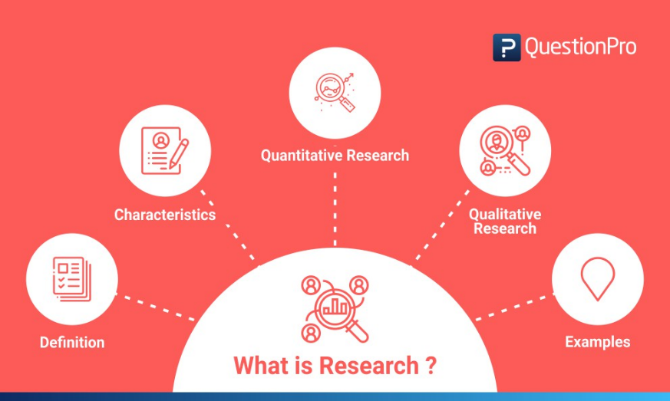Research is the careful consideration of study regarding a particular concern or research problem using scientific methods. According to the American sociologist Earl Robert Babbie, “Research is a systematic inquiry to describe, explain, predict, and control the observed phenomenon. It involves inductive and deductive methods.”

Inductive methods analyze an observed event, while deductive methods verify the observed event. Inductive approaches are associated with qualitative research, and deductive methods are more commonly associated with quantitative analysis.

* **RESEARCH METHODOLOGY:**

Research methodology is a way of explaining how a researcher intends to carry out their research. It's a logical, systematic plan to resolve a research problem. A methodology details a researcher's approach to the research to ensure reliable, valid results that address their aims and objectives. It encompasses what data they're going to collect and where from, as well as how it's being collected and analysed.

1. ABOUT THE RESEARCH
2. **RESEARCH TITLE**

A Study on Customer Satisfaction Towards Maruti Suzuki Cars in Surat City.

1. **NEED AND SCOPE OF RESEARCH**

* **NEED OF RESEARCH**

The present Indian automobile market shows tremendous growth opportunities for small cars manufactures. The increase in fuel price, interest rate and slowing economic growth are factors defer the customer from purchase of cars. The study will be valuable for both marketers and small to determine the customer preferences of model, segment, and brand of cars. The study will enlighten the marketer about the customer purchase behaviour, pattern, influencing factors, etc. The analysis will help for outlining the marketing strategies for car manufactures.

* **SCOPE OF RESEARCH**

This study will provide solutions to the car manufactures to understand customer’s behaviour. Through this study management will know:

* The reason why people opt four-wheeler.
* To know the features considered by the customers while purchasing a car.
* To know the most preferred brand by the customers.
* The scope of the study is restricted up to the Surat City.

1. **RESEARCH PROBLEM STATEMENT**

Consumer choice process is a complex phenomenon. Making a decision to buy a product or services involves many processes. The literature on brand preference studies reveals that for the selection of passenger cars, the customer has to spend much time to evaluate and choose the desired one based on their need and economic condition. The marketing strategies followed by the manufacturer and marketer as well as pre-conceived idea of the buyer also play a vital role in selection of a particular brand and to get more satisfied. Only a limited number of attempts have been made to study the impact of brand preference factors on customer satisfaction. Based on these basic questions, the researcher has developed an interest to study the factors contributing brand preference of passenger cars and its impact on customer satisfaction level.

1. RESEARCH OBJECTIVE
2. To know the most preferred model of Maruti Suzuki car.
3. To identify important factors while customer choose a car.
4. To find out the factors that influences the people to buy Maruti Suzuki cars.
5. To identify the level of customer satisfaction towards buying of Maruti Suzuki cars.
6. VARIABLES OF THE STUDY

In research, variables are any characteristics that can take on different values, such as height, age, temperature, or test scores. Researchers often manipulate or measure independent and dependent variables in studies to test cause-and-effect relationships. The independent variable is the cause. The dependent variable is the effect.

1. **INDEPENDENT VARIABLE**

The term "independent variable" typically refers to a variable that is manipulated or changed in an experiment or study to observe its effect on the dependent variable. In the context of Maruti Suzuki or any automotive company, independent variables could be various factors that the company can control or manipulate. Here are some potential independent variables for Maruti Suzuki:

**Product Features and Innovations:** Introducing new features, technological advancements, or innovative designs in their vehicles can be an independent variable to measure consumer preferences and market demand.

**Production and Supply Chain Strategies:** Adjusting production levels, manufacturing processes, or supply chain strategies can impact the availability of vehicles in the market.

**Distribution Channels:** Changing the distribution channels, like expanding or contracting the dealership network, can be an independent variable affecting the accessibility of Maruti Suzuki vehicles to consumers.

**Brand Image and Reputation Management:** Efforts to enhance or protect the brand image and reputation can be considered as independent variables, influencing customer loyalty and trust.

1. **DEPENDENT VARIABLE**

The dependent variable in the context of Maruti Suzuki, or any business, is the variable that is observed and measured to assess the impact of changes in the independent variables. In the case of Maruti Suzuki, the dependent variable would typically be a measure of the company's performance, market success, or customer response. Here are some potential dependent variables for Maruti Suzuki:

**Price of the Vehicles:** Maruti Suzuki can adjust the prices of its vehicles as an independent variable to study the impact on sales or market share.

**Marketing and Advertising Spending:** The amount of money spent on marketing and advertising campaigns can be varied to see how it affects brand awareness, customer perception, and sales.

**Sales Revenue:** The total revenue generated from the sales of Maruti Suzuki vehicles is a key indicator of the company's financial performance.

**Market Share:** The percentage of the total market for automobiles that Maruti Suzuki occupies is a common measure of its competitiveness and success.

**Customer Satisfaction:** Surveys or other metrics assessing customer satisfaction and loyalty can be considered dependent variables, reflecting the impact of various business strategies on customer perception.

**Profit Margins:** The profitability of Maruti Suzuki, as measured by profit margins, net income, or return on investment, can be a dependent variable reflecting the financial success of the company.

**Vehicle Quality and Reliability:** Metrics related to the quality and reliability of Maruti Suzuki vehicles, such as customer complaints or recalls, can be dependent variables reflecting the impact of manufacturing and design decisions.

**Promotional Strategies:** The way Maruti Suzuki promotes its products, such as through discounts, special offers, or financing options, can be manipulated to observe its influence on consumer behaviour.

1. RESEARCH DESIGN

Research design is the framework of research methods and techniques chosen by a researcher to conduct a study. The design allows researchers to sharpen the research methods suitable for the subject matter and set up their studies for success.

* **EXPLORATORY RESEARCH DESIGN**

Exploratory research is defined as research used to investigate a problem which is not clearly defined. It is conducted to have a better understanding of the existing research problem, but will not provide conclusive results. For such research, a researcher starts with a general idea and uses this research as a medium to identify issues, that can be the focus for future research. An important aspect here is that the researcher should be willing to change his/her direction subject to the revelation of new data or insight. Such research is usually carried out when the problem is at a preliminary stage. It is often referred to as grounded theory approach or interpretive research as it used to answer questions like what, why and how.

* **DESCRIPTIVE RESEARCH DESIGN**

Descriptive research aims to accurately and systematically describe a population, situation or phenomenon. It can answer what, where, when and how questions, but not why questions. A descriptive research design can use a wide variety of research methods to investigate one or more variables.

* **CAUSAL RESEARCH DESIGN**

Causal research is classified as conclusive research since it attempts to build a cause-and-effect link between two variables. This research is mainly used to determine the cause of particular behaviour. We can use this research to determine what changes occur in an independent variable due to a change in the dependent variable.

It can assist you in evaluating marketing activities, improving internal procedures, and developing more effective business plans. Understanding how one circumstance affects another may help you determine the most effective methods for satisfying your business needs.

* This is **Descriptive** type of research helps to understand or identify the degree of customer satisfaction, opinions, experience in relation to quality and service factors of Maruti Suzuki service. Descriptive Research type is used to diagnose the customer experience that leads to customer satisfaction. A structured questionnaire was designed by using close ended questions which includes satisfactory scale or satisfactory rating scale, Rating scale or Response scale. Satisfaction rating scale is utilised to calculate levels of satisfaction or dissatisfaction with a particular product, service or experience. Response scale is utilised to evaluate opinions or evaluations on particular attribute or item.

1. DATA COLLECTION
2. **SOURCES OF DATA**

* **Primary Data:** Primary Data was collected through Offline & Online Structured Questionnaire.
* **Secondary Data:** Secondary data are readily available information’s from different websites, journals, article, magazines etc.

1. **INSTRUMENT USED FOR DATA COLLECTION**

The following statistical tools were used for analysis.

1. Offline
2. Online (Google Form)
3. **DATA COLLECTION PERIOD**

* The data collection period for this research study is from 21st January 2024 to 5th February 2024.

1. SAMPALING DESIGN
2. **TARGET POPULATION**

The Research Consider the target population of Maruti Suzuki car owner and other company’s car owner in Surat city.

1. **SAMPLING ELEMENT**

The sampling elements of this research study included Men & Women, aged between 18-50 years.

1. **SAMPLE SIZE**

Total 275 respondents out of the total population has been included.

1. **SAMPLING TECHNIQUE**

Sampling techniques can be classified into two, those falling under the Probabilistic approach, and those under the non-Probabilistic approach. These two approaches are explained as follows:

* Probabilistic sampling techniques include Simple Random Sampling, Systematic Sampling, Stratified Sampling and Cluster Sampling.
* Non-Probabilistic sampling techniques include Convenience Sampling, Snowball Sampling, Judgmental Sampling and Quota Sampling.

In this particular research study, the technique of **Convenience Sampling** has been used for data collection.

1. DATA PROCESSING
2. **DATA ANALYSIS TOOLS**

Various data analysis tools like SPSS, Graphs & Charts, and Microsoft Excel will be used to analyze the data.

1. **DATA REPRESENTATION TOOL**

The data collected, and analysed is represented with the help of Tables, Bar Charts and Pie Charts, made using the MS Excel software & SPSS software.

1. LIMITATIONS OF THE REPORT

* The target customers are who own a car earlier and at present and this study didn’t include the customers who have an intention to buy a car in future.
* Some customers don’t share their valuable time to answer the questionnaire.
* The information given by some customers may not be accurate.
* The data was collected only in the area of Surat city

1. CHAPTERISATION OF THE REPORT

|  |  |
| --- | --- |
| CHAPTER NO. | CHAPTER NAME |
| 1 | Introduction |
| 2 | Review of Literature |
| 3 | Research Methodology |
| 4 | Data Analysis and Interpretation |
| 5 | Findings, Conclusions and Recommendations |
|  | Bibliography |
|  | Annexure |

CHAPTER 4

DATA ANALYSIS AND INTERPRETATION

# CHAPTER 4: DATA ANALYSIS AND INTERPRETATION

1. AGE

|  |  |  |  |  |
| --- | --- | --- | --- | --- |
| **Age** | | | | |
|  | | Frequency | Percentage |
| Valid | Below 18 | 10 | 3.6% |
| 19-30 | 190 | 69.1% |
| 31-40 | 60 | 21.8% |
| 41-50 | 13 | 4.7% |
| Above 50 | 2 | 0.7% |
| **Total** | **275** | **100.0%** |

Table 4.1 Age

Figure 4.1 Age

* **INTERPRITATION:**

The above table 4.1 shows the age group of respondents. Out of 275 respondents, majority 190 (69.1%) were from 19-30 year followed by 31-40 years 60 (21.8%). It has been also observed that only 2 (0.7%) respondents belong to Above 50 year of age group.

1. GENDER

|  |  |  |  |
| --- | --- | --- | --- |
| **Gender** | | | |
|  | | Frequency | Percentage |
| Valid | Male | 173 | 62.9% |
| Female | 102 | 37.1% |
| **Total** | **275** | **100.0%** |

Table 4.2 Gender

Figure 4.2 Gender

* **INTERPRITATION:**

The Table 4.2 above explains the gender profile of respondents. Out of 275 respondents,173 (62.9%) were Males and 102 (37.1%) were Female respondents.

1. OCCUPATION

|  |  |  |  |
| --- | --- | --- | --- |
| **Occupation** | | | |
|  | | Frequency | Percentage |
| Valid | Student | 156 | 56.7% |
| Employee | 70 | 25.5% |
| Businessmen | 34 | 12.4% |
| Housewife | 15 | 5.5% |
| **Total** | **275** | **100.0%** |

Table 4.3 Occupation

Figure 4.3 Occupation

* **INTERPRITATION:**

The table 4.3 shows the distribution of respondents based on their occupations in a sample of 275 individuals. The majority of the respondents, comprising 56.7%, are students,25.5% of the respondents are employees, 12.4% of the respondents are engaged in business, 5.5% of the respondents are housewives. So, this table indicate that a significant portion of the respondents are students, followed by employees, businessmen, and housewives.

1. ANNUAL FAMILY INCOME

|  |  |  |  |
| --- | --- | --- | --- |
| **Annual Family Income** | | | |
|  | | Frequency | Percentage |
| Valid | Up to 2,50,000 | 93 | 33.8% |
| 2,50,001-3,00,000 | 52 | 18.9% |
| 3,00,001-5,00,000 | 55 | 20.0% |
| 5,00,001-10,00,000 | 52 | 18.9% |
| Above 10,00,000 | 23 | 8.4% |
| **Total** | **275** | **100.0%** |

Table 4.4 Annual Family Income

Figure 4.4 Annual Family Income

* **INTERPRITATION:**

The Above table 4.4 represents the distribution of annual family income for a sample of 275 respondents. In which 33.8% of the surveyed families have an annual income up to 2,50,000, 18.9% of the families fall in the income range of 2,50,001 to 3,00,000, 20.0% of the families fall in the income range of 3,00,001 to 5,00,000, 18.9% of the families fall in the income range of 5,00,001 to 10,00,000, 8.4% of the families have an annual income above 10,00,000.

1. HAVE A MARUTI SUZUKI CAR

|  |  |  |  |
| --- | --- | --- | --- |
| **Have a Maruti Suzuki Car** | | | |
|  | | Frequency | Percentage |
| Valid | Yes | 243 | 88.4% |
| No | 32 | 11.6% |
| **Total** | **275** | **100.0%** |

Table 4.5 Have a Maruti Suzuki Car

Figure 4.5 Have a Maruti Suzuki Car

[Figure 4.5 Have a Maruti Suzuki Car]

* **INTERPRITATION:**

Table 4.5 shows that in a sample of 275 respondents whether they own a Maruti Suzuki car or not, out of them 243 (88.4%) respondents indicated that they have a Maruti Suzuki car and 32 (11.6%) respondents stated that they do not have a Maruti Suzuki Car. Most of the respondents, 88.4% own a Maruti Suzuki car, while 11.6% do not.

1. MODEL OF MARUTI SUZUKI CAR YOU OWN

|  |  |  |  |
| --- | --- | --- | --- |
| **Model Own** | | | |
|  | | Frequency | Percentage |
| Valid | Swift | 50 | 20.6% |
| Ertiga | 31 | 12.8% |
| Alto 800 | 15 | 6.2% |
| Eeco | 23 | 9.5% |
| WagonR | 25 | 10.3% |
| Ritz | 14 | 5.8% |
| Baleno | 31 | 12.8% |
| Ciaz | 17 | 7.0% |
| Celerio | 4 | 1.6% |
| Grand Vitara | 24 | 9.9% |
| Other | 9 | 3.7% |
| **Total** | **243** | **100.0** |

Table 4.6 Model Own

Figure 4.6 Model Own

* **INTERPRITATION:**

The above table 4.6 interpret information from 243 Maruti Suzuki car owners. Out of them 20.6% of respondents have Swift, 12.8% own an Ertiga, 6.2% own an Alto 800, 9.5% own an Eeco, 10.3% own a WagonR, 5.8% own a Ritz, 12.8% own a Baleno, 7.0% own a Ciaz, 1.6% own a Celerio, 9.9% own a Grand Vitara, and 3.7% own other Maruti Suzuki car models.

1. MOST FAVOURITE COLOUR IN MARUTI SUZUKI CAR

|  |  |  |  |
| --- | --- | --- | --- |
| **Most Favourite Colour** | | | |
|  | | Frequency | Percentage |
| Valid | White | 124 | 51.0% |
| Black | 49 | 20.2% |
| Red | 18 | 7.4% |
| Blue | 12 | 4.9% |
| Brick Red | 7 | 2.9% |
| Silky Silver | 24 | 9.9% |
| Sunlight Copper | 1 | 0.4% |
| Azure Gery | 7 | 2.9% |
| Other | 1 | 0.4% |
| Total | 243 | 100.0% |

Table 4.7 Most Favourite Colour

Figure 4.7 Most Favourite Colour

* **INTERPRITATION:**

The graph 4.7 above shows that the most favourite car's colour purchase by 243 respondents. From which White is the most prevalent colour with 51% of the total sample. The second most common colour Black with 20.2%. Red colour has 7.4% car owners. Blue colour with 4.9%. Brick Red and Azure Grey are covers 2.9% of the total sample. Silky Silver is another common colour with 9.9%. Sunlight Copper is a less common colour with 0.4%. Another miscellaneous colour category with 0.4%.

1. VARIANT YOU LIKE TO PURCHASE MARUTI SUZUKI CAR

|  |  |  |  |
| --- | --- | --- | --- |
| **Fuel Type** | | | |
|  | | Frequency | Percentage |
| Valid | Petrol | 119 | 49.0% |
| Diesel | 53 | 21.8% |
| CNG | 59 | 24.3% |
| Mild Hybrid | 12 | 4.9% |
| **Total** | **243** | **100.0%** |

Table 4.8 Fuel Type

Figure 4.8 Fuel Type

* **INTERPRITATION:**

The data of 4.8 table represents the fuel types of a certain category or set of vehicles, with a total sample size of 243.The 49% of cars own by respondents are Petrol. The second most common fuel type Diesel cars are owned by 21.8% respondents. The cheapest fuel type CNG cars are owned by 24.3%. Mild Hybrid is a less common and new type of fuel technology with 4.9% of owners.

1. MEDIA TOOL THAT INFLUENCED TO BUY MARUTI SUZUKI CAR

|  |  |  |  |  |  |  |
| --- | --- | --- | --- | --- | --- | --- |
| **Media Tools** | | | | | | |
|  |  | Valid | | | | |
| Not at all Influenced | Little Influenced | Significant Influenced | Highly Significant Influenced | Total |
| TV Commercials | Frequency | 3 | 28 | 77 | 135 | 243 |
| Percentage | 1.2% | 11.5% | 31.7% | 55.6% | 100.0% |
| Product Demonstrations | Frequency | 9 | 74 | 112 | 48 | 243 |
| Percentage | 3.7% | 30.5% | 46.1% | 19.8% | 100.0% |
| Radio Advertisement | Frequency | 90 | 67 | 45 | 41 | 243 |
| Percentage | 37.0% | 27.6% | 18.5% | 16.9% | 100.0% |
| Newspaper | Frequency | 14 | 78 | 98 | 53 | 243 |
| Percentage | 5.8% | 32.1% | 40.3% | 21.8% | 100.0% |
| Leaflets | Frequency | 26 | 96 | 82 | 39 | 243 |
| Percentage | 10.7% | 39.5% | 33.7% | 16.0% | 100.0% |
| Word of Mouth | Frequency | 11 | 18 | 50 | 164 | 243 |
| Percentage | 4.5% | 7.4% | 20.6% | 67.5% | 100.0% |
| Holdings | Frequency | 15 | 82 | 96 | 50 | 243 |
| Percentage | 6.2% | 33.7% | 39.5% | 20.6% | 100.0% |
| Instagram Ads | Frequency | 23 | 23 | 63 | 134 | 243 |
| Percentage | 9.5% | 9.5% | 25.9% | 55.1% | 100.0% |
| Facebook Ads | Frequency | 27 | 27 | 66 | 123 | 243 |
| Percentage | 11.1% | 11.1% | 27.2% | 50.6% | 100.0% |

Table 4.9 Media Tools

Figure 4.9 Media Tools

[Figure 4.9 Media Tools]

* **INTERPRITATION:**

In explaining this result, it can be stated from the above table 4.9 TV commercials emerge as a highly significant influencer, with 55.6% of respondents indicating that they are influenced by this medium. While only 1.2% claimed not to be influenced at all. Product demonstrations has 46.1% of respondents considering them as a significant influence, and 30.5% finding them highly influential. Radio advertisements shows lower percentages in influence category, still capture 64.6% of respondents with either significant or highly significant. While newspapers are considered significant or highly significant by 62.1% of respondents, leaflets are perceived as highly significant by only 16.0%. Word of mouth has 67.5% of respondents considering it highly significant. Holdings show a substantial influence on respondents, with over 20.6% reporting some level of influence. Digital media tools, such as Instagram and Facebook ads, demonstrate substantial influence, with 55.1% and 50.6% of respondents, respectively, finding them highly significant.

1. OPINION ABOUT PRICE OF MARUTI SUZUKI CAR

|  |  |  |  |
| --- | --- | --- | --- |
| **Price Opinion** | | | |
|  | | Frequency | Percentage |
| Valid | High | 91 | 37.4% |
| Low | 37 | 15.2% |
| Reasonable | 115 | 47.3% |
| **Total** | **243** | **100.0%** |

Table 4.10 Price Opinion

Figure 4.10 Price Opinion

* **INTERPRITATION:**

The 4.10 table represents the opinion of pricing related to respondent’s car. A significant portion of 37.4% respondents perceives the product or service as having a high price. A smaller proportion of 15.2% respondents considers the product or service to have a low price. The majority of 47.3% respondents of total sample are consider for reasonable price. The majority of Maruti Suzuki car owners consider the price of their car are reasonable.

1. TIME PERIOD OF USING MARUTI SUZUKI CAR

|  |  |  |  |
| --- | --- | --- | --- |
| **How Long Use Car** | | | |
|  | | Frequency | Percentage |
| Valid | 0-5 Year | 76 | 31.3% |
| 6-10 Year | 126 | 51.9% |
| 11-15 Year | 33 | 13.6% |
| 16 Above | 8 | 3.3% |
| **Total** | **243** | **100.0%** |

Table 4.11 How Long Use Car

Figure 4.11 How Long Use Car

* **INTERPRITATION:**

The provided data from table 4.11 indicates the time duration of car owners with their car, with the total respondents of 243.A significant portion of 31.3% respondents reported using cars within the first 5 years of ownership. The most common duration range of 51.9% for car usage, indicating that a significant number of respondents have owned their cars for 6 to 10 years. With 13.6% of respondents are smaller but notable proportion of using cars for 11 to 15 years. The smallest portion of respondents reported using cars for 16 years or more are 3.3%.

1. FIRST PREFERENCE TO MARUTI SUZUKI WHILE BUYING CAR

|  |  |  |  |  |
| --- | --- | --- | --- | --- |
| **First Preference** | | | | |
|  | | Responses | | Percent of Cases |
| N | Percentage |
| First Preference | Good Facility | 153 | 18.9% | 63.0% |
| Quality Service | 132 | 16.3% | 54.3% |
| Good Design | 109 | 13.5% | 44.9% |
| Better Mileage | 173 | 21.4% | 71.2% |
| Price | 161 | 19.9% | 66.3% |
| All of the Above | 82 | 10.1% | 33.7% |
| Total | | 810 | 100.0% | 333.3% |

Table 4.12 First Preference

Figure 4.12 First Preference

* **INTERPRITATION:**

Table 4.12 is significantly related to the overall preference for buying the Maruti Suzuki car. In which the preference are divided into different categories like: Good Facility 18.9%, Quality Service by 16.3%, Good Design with 13.5%, Better Mileage 21.4%, Price by 19.9% and at last option all of the Above with 10.1% of respondents. Mostly respondents are overall look for better milage and best price while purchasing the car.

1. OPINION ABOUT SERVICE OF MARUTI SUZUKI WITH OTHER COMPANY

|  |  |  |  |
| --- | --- | --- | --- |
| **Service Comparing with Other** | | | |
|  | | Frequency | Percentage |
| Valid | Poor | 1 | 0.4% |
| Average | 13 | 5.3% |
| Good | 42 | 17.3% |
| Very Good | 74 | 30.5% |
| Excellent | 113 | 46.5% |
| **Total** | **243** | **100.0%** |

Table 4.13 Service Opinion

Figure 4.13 Service Opinion

* **INTERPRITATION:**

The data presented in above table 4.13 illustrates a comprehensive assessment of a service based on user feedback. The majority of respondents, comprising 46.5% of the total sample size rated the service as Excellent. Following closely, 30.5% of participants deemed the service Very Good. Moreover, 17.3% of respondents rated the service as Good. A smaller proportion of 5.3% respondents found the service to be Average and lastly only 0.4% respondent rated as Poor.

1. FEATURE OF MARUTI SUZUKI CAR

|  |  |  |  |  |  |  |  |
| --- | --- | --- | --- | --- | --- | --- | --- |
| **Feature** | | | | | | | |
|  |  | Valid | | | | | |
| Poor | Average | Good | Very Good | Excellent | Total |
| Facilities | Frequency | 1 | 9 | 50 | 77 | 106 | 243 |
| Percentage | 0.4% | 3.7% | 20.6% | 31.7% | 43.6% | 100.0% |
| Design | Frequency | 1 | 13 | 75 | 109 | 45 | 243 |
| Percentage | 0.4% | 5.3% | 30.9% | 44.9% | 18.5% | 100.0% |
| Service | Frequency | 3 | 19 | 86 | 79 | 56 | 243 |
| Percentage | 1.2% | 7.8% | 35.4% | 32.5% | 23.0% | 100.0% |
| Mileage | Frequency | 4 | 15 | 39 | 56 | 129 | 243 |
| Percentage | 1.6% | 6.2% | 16.0% | 23.0% | 53.1% | 100.0% |

Table 4.14 Feature

Figure 4.14 Feature

[Figure 4.14 Feature]

* **INTERPRITATION:**

Table 4.14 presents the detailed analysis of user perceptions regarding distinct features of a service offer by Maruti Suzuki. It is evident that the majority of respondents, comprising 43.6% of the total sample, rated them as Excellent. An additional 31.7% considered the facilities Very Good. Moving on to Design, the largest proportion of participants, at 44.9%, deemed it Excellent and 30.9% rated the Design as Very Good. The category of Service showed 35.4% of respondents rating it as Excellent, and 32.5% considering it Very Good. Finally, Mileage received a substantial 53.1% of respondents labelling it as Excellent and 23.0% found the Mileage to be Very Good.

1. OVERALL OPINION ABOUT MARUTI SUZUKI CAR

|  |  |  |  |
| --- | --- | --- | --- |
| O**verall Opinion** | | | |
|  | | Frequency | Percentage |
| Valid | Bad | 6 | 2.5% |
| Neutral | 40 | 16.5% |
| Good | 85 | 35.0% |
| Very Good | 112 | 46.1% |
| **Total** | **243** | **100.0%** |

Table 4.15 Overall Opinion

Figure 4.15 Overall Opinion

* **INTERPRITATION:**

The graph 4.15 above shows that overall opinions about the service of 243 respondents. A significant 46.1% of participants rated their overall experience as Very Good. Following closely, 35.0% of respondents regarded the service as Good. Additionally, 16.5% expressed a Neutral opinion, suggesting a moderate stance. A smaller portion of 2.5%, considered the service to be Bad. While this negative perception is present, it is noteworthy that the majority of respondents provided positive feedback, contributing to an overall positive outlook for the service.

1. EXPECTING CHANGES IN MARUTI SUZUKI CAR

|  |  |  |  |  |
| --- | --- | --- | --- | --- |
| **Expecting Changes Frequencies** | | | | |
|  | | Responses | | Percent of Cases |
| N | Percentage |
| Expecting Changes | Increase Safety | 161 | 34.5% | 66.3% |
| Add New Facilities | 99 | 21.2% | 40.7% |
| Increase Mileage | 45 | 9.7% | 18.5% |
| Introduce EV Model | 110 | 23.6% | 45.3% |
| Changes Design | 51 | 10.9% | 21.0% |
| Total | | 466 | 100.0% | 191.8% |

Table 4.16 Expecting Changes

Figure 4.16 Expected Changes

* **INTERPRITATION:**

The data of table 4.16 presents the changes that are respondents expecting in the car segment of Maruti Suzuki. A notable 34.5% of participants expressed a desire for changes aimed at increasing safety. The 23.6% of respondents highlighted the importance of introducing an Electric Vehicle model, reflecting a growing interest in eco-friendly transportation options. New facility additions were also a significant expectation, with 21.2% of respondents. Moreover, 10.9% of participants expressed a desire for changes in design. Surprisingly, 9.7% of respondents specifically mentioned an increase in mileage as an expected change.

1. FULL-SIZE SUV CAR SEGMENT WILL IMPROVE SALES OF MARUTI SUZUKI CAR

|  |  |  |  |
| --- | --- | --- | --- |
| **Full-size SUV Segment** | | | |
|  | | Frequency | Percentage |
| Valid | Yes | 121 | 49.8% |
| No | 23 | 9.5% |
| Maybe | 99 | 40.7% |
| **Total** | **243** | **100.0%** |

Table 4.17 Full-Size SUV Segment

Figure 4.17 Full-Size SUV Segment

* **INTERPRITATION:**

The data of table 4.17 pertaining to respondents' preferences within the full-size SUV segment indicates a diverse range of opinions. The half of the respondents 49.8% expressed a clear inclination towards the full-size SUV segment. A smaller percentage of 9.5% respondents stated a definite preference against full-size SUVs. However, the 40.7% fell into the 'Maybe' category, indicating a level of uncertainty to considering full-size SUVs. The data underscores the need for a nuanced understanding of consumer preferences within the full-size SUV segment.

1. MARUTI SUZUKI IN TERM OF RELIABILITY AND TRUSTWORTHINESS

|  |  |  |  |  |  |  |  |
| --- | --- | --- | --- | --- | --- | --- | --- |
| **Reliability & Trustworthiness** | | | | | | | |
|  |  | Valid | | | | | |
| Poor | Average | Good | Very Good | Excellent | Total |
| Safety | Frequency | 32 | 42 | 57 | 42 | 70 | 243 |
| Percentage | 13.2% | 17.3% | 23.5% | 17.3% | 28.8% | 100.0% |
| Value for Money | Frequency | 1 | 8 | 48 | 91 | 95 | 243 |
| Percentage | 0.4% | 3.3% | 19.8% | 37.4% | 39.1% | 100.0% |
| Japanese Manufacturing Principle | Frequency | 0 | 11 | 85 | 97 | 50 | 243 |
| Percentage | 0% | 4.5% | 35.0% | 39.9% | 20.6% | 100.0% |
| Market Leader of Passenger Vehicle Production | Frequency | 4 | 13 | 72 | 101 | 53 | 243 |
| Percentage | 1.6% | 5.3% | 29.6% | 41.6% | 21.8% | 100.0% |
| Loyalty | Frequency | 6 | 15 | 71 | 93 | 58 | 243 |
| Percentage | 2.5% | 6.2% | 29.2% | 38.3% | 23.9% | 100.0% |
| Engagement | Frequency | 2 | 25 | 82 | 98 | 36 | 243 |
| Percentage | 0.8% | 10.3% | 33.7% | 40.3% | 14.8% | 100.0% |
| Advocacy | Frequency | 9 | 23 | 75 | 92 | 44 | 243 |
| Percentage | 3.7% | 9.5% | 30.9% | 37.9% | 18.1% | 100.0 |

Table 4.18 Reliability & Trustworthiness

Figure 4.18 Reliability and Trustworthiness

* **INTERPRITATION:**

As reflected in table 4.18 the perceptions of respondents regarding the reliability and trustworthiness of a product across various dimensions. Safety has the majority of respondents rated it as Very Good with 28.8% and 13.2% who rated it as Poor. While value for money, a significant portion of respondents, 39.1%, deemed it Excellent. A small percentage, 0.4% rating it as Poor. The Japanese Manufacturing Principle received positive feedback, with a combined 39.9% rating it as Very Good. However, not an once respondent rated it as Poor. As a market leader in passenger vehicle production rated 41.6% as Very Good. Also, the 1.6% respondents considered it as Poor. Loyalty garnered favourable responses, with a 38.3% rating it as Very Good. While, there is a notable 2.5% who rated it as Poor. In terms of engagement, 40.3% of respondents rated it as Very Good. However, the 0.8% who rated it as Poor. Lastly, advocacy received positive feedback, with 37.9% rating it as Very Good. The 3.7% respondents rated it as Poor.

1. CONSIDER A MARUTI SUZUKI CAR FOR NEXT PURCHASE

|  |  |  |  |
| --- | --- | --- | --- |
| **Next Purchase** | | | |
|  | | Frequency | Percentage |
| Valid | Yes | 158 | 65.0% |
| No | 29 | 11.9% |
| Maybe | 56 | 23.0% |
| **Total** | **243** | **100.0%** |

Table 4.19 Next Purchase

Figure 4.19 Next Purchase

* **INTERPRITATION:**

The table 4.19 provides insights into the likelihood of making a next purchase out of 243 respondents. The majority of 65.0% respondents expressed a positive inclination with a definite "Yes." While, a smaller portion of 11.9% indicated a clear "No," implying that a distinct group is not currently considering a next purchase. A significant proportion, 23.0%, falls into the "Maybe" category, indicating a level of uncertainty or hesitation among respondents.

1. FACTOR INFLUENCED TO CHOOSE A MARUTI SUZUKI CAR

|  |  |  |  |  |
| --- | --- | --- | --- | --- |
| **Factors Influenced Frequencies** | | | | |
|  | | Responses | | Percent of Cases |
| N | Percentage |
| Factors Influenced | Low Price | 146 | 30.2% | 60.1% |
| Fuel Efficiency | 128 | 26.4% | 52.7% |
| Brand Reputation | 76 | 15.7% | 31.3% |
| Feature and Technology | 63 | 13.0% | 25.9% |
| After Sales Service | 71 | 14.7% | 29.2% |
| **Total** | | **484** | **100.0%** | **199.2%** |

Table 4.20 Factor Influenced

Figure 4.20 Factor Influenced

* **INTERPRITATION:**

In relation with the result of table 4.20. It may be constructed that the factors that influence respondents when making purchasing decisions, with a total of 484 responses. Among the factors, "Low Price" emerges as the most prevalent, impacting 30.2% of cases. "Fuel Efficiency" is influencing 26.4% of the respondents who prioritize this factor. "Brand Reputation" has over 15.7% of respondents. "Feature and Technology" influence 13.0% of cases. Lastly, "After Sales Service" is a factor with 14.7% of respondents.

1. OVERALL PERFORMANCE OF MARUTI SUZUKI CAR

|  |  |  |  |
| --- | --- | --- | --- |
| **Overall Performance** | | | |
|  | | Frequency | Percentage |
| Valid | Very Dissatisfied | 1 | 0.4% |
| Dissatisfied | 11 | 4.5% |
| Neutral | 39 | 16.0% |
| Satisfied | 87 | 35.8% |
| Very Satisfied | 105 | 43.2% |
| **Total** | **243** | **100.0%** |

Table 4.21 Overall Performance

Figure 4.21 Overall Performance

* **INTERPRITATION:**

The above table 4.21 provides the overall satisfaction levels of respondents regarding to the product's performance, with a total of 243 respondents. The majority of respondents express positive response, with 35.8% reported as "Satisfied," and an even more substantial 43.2% claimed to be "Very Satisfied." Additionally, a significant proportion of respondents, 16.0%, indicated a "Neutral" stance. A small percentage of 4.5% reported as "Dissatisfied," and an even smaller 0.4% indicating being "Very Dissatisfied."

1. SATISFACTION OF AFTER-SALES SERVICE

|  |  |  |  |  |  |  |  |
| --- | --- | --- | --- | --- | --- | --- | --- |
| **Satisfaction of After-sales Service** | | | | | | | |
|  |  | Valid | | | | | |
| Poor | Average | Good | Very Good | Excellent | Total |
| Maintenance | Frequency | 1 | 17 | 84 | 62 | 79 | 243 |
| Percentage | 0.4% | 7.0% | 34.6% | 25.5% | 32.5% | 100.0% |
| Vehicle pick-up | Frequency | 0.0 | 9 | 54 | 78 | 102 | 243 |
| Percentage | 0.0% | 3.7% | 22.2% | 32.1% | 42.0% | 100.0% |
| Service advisor | Frequency | 1 | 18 | 107 | 77 | 40 | 243 |
| Percentage | 0.4% | 7.4% | 44.0% | 31.7% | 16.5% | 100.0% |
| Availability of Parts | Frequency | 0.0 | 15 | 61 | 108 | 59 | 243 |
| Percentage | 0.0% | 6.2% | 25.1% | 44.4% | 24.3% | 100.0% |
| Availability of Service station | Frequency | 5 | 19 | 50 | 96 | 73 | 243 |
| Percentage | 2.1% | 7.8% | 20.6% | 39.5% | 30.0% | 100.0% |
| Repairs | Frequency | 3 | 33 | 87 | 75 | 45 | 243 |
| Percentage | 1.2% | 13.6% | 35.8% | 30.9% | 18.5% | 100.0% |
| Customer Support | Frequency | 14 | 65 | 57 | 53 | 54 | 243 |
| Percentage | 5.8% | 26.7% | 23.5% | 21.8% | 22.2% | 100.0% |

Table 4.22 After-Sales Service

Figure 4.22 After-Sales Service

* **INTERPRITATION:**

Table 4.22 presents the satisfaction levels of 243 respondents across various aspects of after-sales service of Maruti Suzuki. Maintenance appears a significant portion of 34.6% respondents rated it as either Good or Very Good and 0.4% respondent gives it Poor rating. The vehicle pick-up has highest 42% rating for Excellent, and no Poor rating in compare to other. In terms of service advisor, there is a notable 44% of satisfaction levels, particularly in the good category and 0.4% respondent rate this in Poor category. The highest rating received by Availability of parts 44.4% falls in good category. The 39.5% of respondents rank company service in Very Good and some 2.9% rank company in Poor category. While repairs received a 35.8% of good ratings, there is a significant portion of 1.2% respondents who rated it as Average or Poor. Customer support, although receiving a 23.5% of good rating and shows a slightly higher proportion of 5.8% respondents rating it as Poor or Average compared to other aspects.

1. RECOMMEND MARUTI SUZUKI TO FRIENDS OR FAMILY

|  |  |  |  |
| --- | --- | --- | --- |
| **Recommend** | | | |
|  | | Frequency | Percentage |
| Valid | Yes | 197 | 81.1% |
| No | 13 | 5.3% |
| Maybe | 33 | 13.6% |
| **Total** | **243** | **100.0%** |

Table 4.23 Recommend

Figure 4.23 Recommend

* **INTERPRITATION:**

Table 4.23 indicates the customer recommendations to their Friends and Family for Maruti Suzuki cars. Among the respondents, the majority of 81.1% answered "Yes". On the other hand, only a small portion of 5.3% responded with a "No," suggesting a low level of dissatisfaction. Meanwhile, 13.6% of respondents opted for "Maybe," indicating some uncertainty or mixed feelings about recommending the aspect.

1. REASONS FOR NOT CHOOSING MARUTI SUZUKI CAR

|  |  |  |  |  |
| --- | --- | --- | --- | --- |
| **Reasons for Not Choosing Frequencies** | | | | |
|  | | Responses | | Percent of Cases |
| N | Percentage |
| Reasons for Not Choosing | Safety Issues | 28 | 38.4% | 87.5% |
| Quality Issues | 20 | 27.4% | 62.5% |
| Feature Issues | 11 | 15.1% | 34.4% |
| Design Issues | 14 | 19.2% | 43.8% |
| **Total** | | **73** | **100.0%** | **228.1%** |

Table 4.24 Reasons for not Choosing

Figure 4.24 Reasons for not Choosing

* **INTERPRITATION:**

The above table 4.24 outlines reasons for not purchasing the Maruti Suzuki car from respondents. Among the reasons, safety issues were the most prevalent, with 38.4% of respondents. This suggests that safety is a paramount consideration for customers when making decisions. Quality issues followed closely behind by 27.4% of respondents, indicating that the perceived quality of the product or service plays a crucial role in their decision-making process. Feature issues were mentioned by 15.1% of respondents. Finally, design issues were cited by 19.2% of respondents, suggesting that aesthetic or ergonomic considerations also impact their choices.

* **CROSSTABULATION**

1. HAVE A MARUTI SUZUKI CAR & MARUTI SUZUKI CAR MODEL OWN

|  |  |  |  |  |  |  |  |  |  |  |  |  |  |
| --- | --- | --- | --- | --- | --- | --- | --- | --- | --- | --- | --- | --- | --- |
| **Have a Maruti Suzuki Car * Model Own Crosstabulation** | | | | | | | | | | | | | |
|  | | Model Own | | | | | | | | | | | Total |
| Swift | Ertiga | Alto 800 | Eeco | WagonR | Ritz | Baleno | Ciaz | Celerio | Grand Vitara | Other |
| Have a Maruti Suzuki Car | Yes | 50 | 31 | 15 | 23 | 25 | 14 | 31 | 17 | 4 | 24 | 9 | 243 |
| Total | | 50 | 31 | 15 | 23 | 25 | 14 | 31 | 17 | 4 | 24 | 9 | 243 |

Table 4.25 Have a Maruti Suzuki Car & Maruti Suzuki Car Own

Figure 4.25 Have a Maruti Suzuki Car & Maruti Suzuki Car Model Own

* **INTERPRITATION:**

The above crosstabulation table 4.25.1 presents data on the ownership distribution of various models of Maruti Suzuki cars among surveyed individuals. Out of them each respondents owns at least one Maruti Suzuki car. Swift is the most popular choice, with 50 owners, followed closely by the Ertiga and Baleno, each with 31 owners. The WagonR also shows significant ownership, with 25 individuals. On the other hand, models like the Celerio and Grand Vitara have comparatively lower ownership, with 4 and 24 owners respectively. Interestingly, the category labelled "Other" also accounts for a portion of ownership, with 9 individuals owning cars that fall under this classification. This cross tabulation reveals a diverse distribution of ownership across various Maruti Suzuki models, reflecting the varying preferences of consumers within the brand's line-up.

1. TIME PERIOD OF USING MARUTI SUZUKI CAR & OVERALL OPINION ABOUT MARUTI SUZUKI CAR

|  |  |  |  |  |  |  |
| --- | --- | --- | --- | --- | --- | --- |
| **How Long Use Car * Overall Opinion Crosstabulation** | | | | | | |
|  | | Overall Opinion | | | | Total |
| Bad | Neutral | Good | Very Good |
| How Long Use Car | 0-5 Year | 1 | 19 | 29 | 27 | 76 |
| 6-10 Year | 2 | 15 | 41 | 68 | 126 |
| 11-15 Year | 3 | 5 | 12 | 13 | 33 |
| 16 Above | 0 | 1 | 3 | 4 | 8 |
| Total | | 6 | 40 | 85 | 112 | 243 |

Table 4.26 Time Period of Using Maruti Suzuki Car & Overall Opinion about Maruti Suzuki Car

Figure 4. 26 Time Period of Using Maruti Suzuki Car & Overall Opinion About Maruti Suzuki Car

* **INTERPRITATION:**

The cross-tabulation table 4.25.2 illustrates the correlation between the duration of car usage and the overall opinion of the car among surveyed respondents. Among cars used for 0-5 years, the majority of 29 respondents hold a good opinion, followed by 27 individuals with a Very Good opinion. Conversely, only 1 respondent reported a Bad opinion within this usage duration. For cars used between 6-10 years, opinions are more varied, with 41 individuals reporting a good opinion and 68 individuals expressing a Very Good opinion, indicating generally positive sentiment. However, among cars used for 11-15 years, only 12 individuals hold a good opinion and 13 individuals express a Very Good opinion, while 3 individuals report a Bad opinion. In the oldest category of cars, those used for 16 years and above, the number of respondents is lower, with only a few expressing opinions, mostly falling into the Good and Very Good categories

1. MODEL OWN & FUEL TYPE

|  |  |  |  |  |  |  |  |  |  |  |  |  |  |
| --- | --- | --- | --- | --- | --- | --- | --- | --- | --- | --- | --- | --- | --- |
| **Fuel Type * Model Own Crosstabulation** | | | | | | | | | | | | | |
|  | | Model Own | | | | | | | | | | | Total |
| Swift | Ertiga | Alto 800 | Eeco | WagonR | Ritz | Baleno | Ciaz | Celerio | Grand Vitara | Other |  |
| Fuel Type | Petrol | 26 | 4 | 7 | 9 | 20 | 5 | 26 | 9 | 3 | 6 | 4 | 119 |
| Diesel | 15 | 11 | 2 | 1 | 1 | 6 | 3 | 7 | 0 | 5 | 2 | 53 |
| CNG | 9 | 16 | 6 | 13 | 4 | 3 | 2 | 1 | 1 | 2 | 2 | 59 |
| Mild Hybrid | 0 | 0 | 0 | 0 | 0 | 0 | 0 | 0 | 0 | 11 | 1 | 12 |
| Total | | 50 | 31 | 15 | 23 | 25 | 14 | 31 | 17 | 4 | 24 | 9 | 243 |

Table 4.27 Model Own & Fuel Type

Figure 4.27 Model Own & Fuel Type

* **INTERPRITATION:**

As reflected in the table 4.25.3, there are relationship between fuel types and the ownership distribution of various Maruti Suzuki car models among surveyed respondents. Among cars powered by Petrol, the Swift emerges as the most commonly owned model, with 26 individuals, followed by the Baleno and WagonR, each with 26 and 20 owners respectively. Diesel-powered cars show a different ownership pattern, with the Ertiga having the highest ownership at 11 individuals. Notably, the Grand Vitara and Celerio do not have any Diesel variant. Cars using CNG as fuel has Ertiga being the most commonly owned model among users, followed by the WagonR and Alto 800. However, the Mild Hybrid category is unique, with all respondents owning either the Grand Vitara or the "Other" models, such as hybrids, reflecting a distinct preference for eco-friendly options in this subset.

1. PRICE OPINION & MARUTI SUZUKI MODEL OWN

|  |  |  |  |  |  |  |  |  |  |  |  |  |  |
| --- | --- | --- | --- | --- | --- | --- | --- | --- | --- | --- | --- | --- | --- |
| **Price * Model Own Crosstabulation** | | | | | | | | | | | | | |
|  | | Model Own | | | | | | | | | | | Total |
| Swift | Ertiga | Alto 800 | Eeco | WagonR | Ritz | Baleno | Ciaz | Celerio | Grand Vitara | Other |  |
| Price | High | 18 | 9 | 6 | 5 | 8 | 6 | 15 | 6 | 3 | 13 | 2 | 91 |
| Low | 11 | 5 | 1 | 7 | 3 | 0 | 4 | 3 | 0 | 1 | 2 | 37 |
| Reasonable | 21 | 17 | 8 | 11 | 14 | 8 | 12 | 8 | 1 | 10 | 5 | 115 |
| Total | | 50 | 31 | 15 | 23 | 25 | 14 | 31 | 17 | 4 | 24 | 9 | 243 |

Table 4.28 Price Opinion & Maruti Suzuki Model Own

Figure 4.28 Price Opinion & Maruti Suzuki Model Own

* **INTERPRETATION:**

The graph 4.28 above shows that the relationship between the price range of Maruti Suzuki car models and their ownership distribution among surveyed individuals. Among cars in the High price range, the Baleno emerges as the most commonly owned model, with 15 individuals owning it, closely followed by the Swift with 18 owners. Other models such as the Ertiga and Ciaz also show considerable ownership in this price category. Conversely, cars categorized as Low price have a different ownership distribution, with the Swift having the highest ownership at 11 individuals, followed by the Ertiga with 9 owners. Notably, the Ritz and Celerio have no owners in the Low-price category. Cars falling under the Reasonable price range exhibit a varied ownership pattern, with the Ciaz being the most commonly owned model, followed by the Swift and Baleno.

CHAPTER 5

FINDINGS

# CHAPTER 5: FINDINGS AND CONCLUSION

1. GENERAL FINDINGS

* Form the total respondent’s majority are Males 62.90% and rest are Females.
* There are majority of respondents falls in 19-30 year age groups i.e. 69.10% and low respondents are falls in above 50 year age group i.e. 0.70%
* Out of the total respondents most of are students with 56.70% and rest of the respondents are falls in Employee, Businessmen and Housewife’s.
* Majority of 33.80% of respondents are comes into Up to 2,50,000 category, 20% of respondents are falls in 3,00,001-5,00,000 category, 2,50,001-3,00,000 and 5,00,001-10,00,000 respondents are shares same portion of 18.9%. The least of 8.4% respondents are falls in Above 10,00,001 category.
* The main reason for not choosing Maruti Suzuki car is Safety with 38.4% of respondents. At the second 27.4% has Quality issues. These two factors are weak point of company.

1. MAJOR FINDINGS

|  |  |  |
| --- | --- | --- |
| **Objectives** | **Questions Related to Objectives** | **Findings Related to Objectives** |
| **To know the most preferred model of Maruti Suzuki car.** | 1. Do you have a MARUTI SUZUKI Car?   **2.** If yes, which model in MARUTI SUZUKI do you own?  **4**. In which variant you like to purchase car in MARUTI SUZUKI?  **13.** Do you feel that the introduction of more models within the Full-size SUV car segment will improve sale of MARUTI SUZUKI?  **14.** How would you rate Maruti Suzuki in terms of brand reliability and trustworthiness? | Out of overall respondents 88.4% have Maruti Suzuki car in which 20.6% owns Swift model. Among them most of 49.0% people are like to go with Petrol fuel car model. Maruti Suzuki car has highest rating in terms of brand reliability and trustworthiness in Market Leader of Passenger Vehicle Production with 41.6% of person. With this reference and brand reputation 49.8% people are feel that introduction of full-size SUV segment improves company’s product line. |
| **To identify important factors while customer choose a car.** | **3.** Which is your most favourite colour in car of MARUTI SUZUKI?  **6**. Opinion about price of MARUTI SUZUKI cars?  **7.** Why are you giving first preference to MARUTI SUZUKI while buying car? | The half of the 51.0% owners own or prefer White colour, because it is very less maintenance colour among other colour in automobile industry. The pricing factor is also important factor with 47.3% of respondents, who finds it as Reasonable. However, the Milage is also notable factor for buying a new car. |
| **To identify the level of customer satisfaction towards buying of Maruti Suzuki cars.** | **8.** How long you are using MARUTI SUZUKI car?  **9**. What is your opinion about service of MARUTI SUZUKI comparing with others?  **11.** What is your overall opinion about MARUTI SUZUKI**?**  **12.**What kind of changes are you expecting in the car segment of MARUTI SUZUKI?    **15**. How likely are you to consider a Maruti Suzuki vehicle for your next purchase?  **17.** How satisfied are you with the overall performance of your Maruti Suzuki vehicle on a scale of 1 to 5 (1 being very dissatisfied, 5 being very satisfied)?  **18**. How satisfied are you with Maruti Suzuki's after-sales service on a scale of 1 to 5?  **19.** Would you recommend Maruti Suzuki to friends or family? | The majority of 51.9% respondents are using their car from 6-10 years time period and has best car service experience with 46.5% from other company. Among them 46.1% respondents have good experience with their car, but among them 34.5% customers expecting better safety in the car. With their overall car experience some portion of 65% respondents are likely to purchase Maruti Suzuki car their next car. However, 43.2% respondents are very satisfied with their car performance. The Maruti Suzuki company’s car has comparatively low maintenance with 34.6% and availability of parts are also main factor for car owners with 44.0%. That’s why 81.1% people recommend Maruti Suzuki car to other people as their opinion |

1. CONCLUSION

The study on satisfaction levels of Maruti Suzuki car owners are found that majority of respondents are male, aged between 19 to 30 years students. Most respondents belong to the lower to middle-income categories, of up to 5,00,000 INR. It's a considerable portion of respondents have been using their cars for 6-10 years, indicating a positive ownership experience, with a significant likelihood to choose Maruti Suzuki for their next purchase. The decision-making process for buying Maruti Suzuki cars appears to be influenced by word of mouth. Respondents giving priority to factors such as affordability, fuel efficiency, and brand reputation when selecting a car. The Swift model emerges as the most preferred, particularly in petrol fuel variant. Maruti Suzuki's brand is perceived favourably for its low maintenance, and availability of spare parts. The introduction of a full-size SUV segment is seen as a positive step to enhancing the company's product line and attracting potential buyers. White emerges as the most preferred car colour due to its perceived low maintenance, while pricing and mileage remain crucial factors in the purchase decision. The significant portion of respondents favouring Maruti Suzuki for its after-sales service. Safety is increasingly becoming an important concern for consumers, with expectations for improvements in this area. A large majority of respondents express satisfaction with their Maruti Suzuki cars and are inclined to recommend them to others, indicating a strong brand loyalty and positive customer sentiment overall.

1. RECOMMENDATION

* Company should give more focus on safety of their vehicle, because it is effect on overall sales of the company.
* Maruti Suzuki has also improve their quality of raw material like metal sheet, interior plastic and etc.
* For improving customer base company has to introduce new full size car segment with new feature and technology.
* Now all the company are focuses on EV segment and future will be for EVs. So, company should introduce new generation of Electric vehicle in market for

better customer base.

**BIBLIOGRAPHY**

# BIBLIOGRAPHY

* **REFERENCES**

Adithya, D. S. (2013, January). Customer Perception and Behaviour of car Owners an Empirical Study in Bangalore City. *GRA - GLOBAL RESEARCH ANALYSIS, 2*(1), 104-107.

Akhila, M., & Thayyullathi, A. T. (2014-2015, October-March). A Study on ustomer Satisfaction towards Maruti Suzuki in Coimbatore. *International Journal of Management and Commerce Innovations, 2*(2), 583-587.

AnanthaLaxmi, R., & Priya, A. S. (2017, April). FACTORS INFLUENCING THE CONSUMERS TOWARDS BUYING MARUTI CARS IN THOOTHUKUDI DISTRICT. *International Journal of Research - GRANTHAALAYAH, 5*(4), 41-51.

Angamuthu, D. (2019, April). A Study on Brand Preference of Select Passenger Cars in Tiruvannamalai Town. *IJEMR, 9*(04), 1-10.

Asok, A., & Sumathi, K. (2015, October). Consumer behaviour with regard to purchase of small cars – A study in Thoothukudi city. *International Journal of Multidisciplinary Research and Development, 2*(10), 645-647.

Bokade, P., Pande, A., & Pendse, D. (2020, April). A REVIEW- RESEARCH PAPER ON CONSUMER BUYING BEHAVIOR TOWARDS MARUTI SUZUKI CARS. *Journal of Emerging Technologies and Innovative Research (JETIR), 7*(4), 186-192.

Chopra, D. (2018, July). Consumer Preference Towards Maruti Suzuki and Hyundai Motors: A Comparative Study of The Automobile Sector. *International Journal of Management Studies, 5*(3(6)), 84-90.

Dhiman, A., & Garg, D. (2022, November). A Study on Consumer Buying Behaviour of Passenger Cars: With Special Reference to NCR. *Journal of Emerging Technologies and Innovative Research (JETIR), 9*(11), C269-C277.

Doshi, V. Y., & Parmar, D. (2016). A Study on Research Articles on Hatchback Cars: Customer Perception and Buying Behaviour. *International Conference on Research & Entrepreneurship (ICRE)*, 1-7.

Doshi, V., & Parmar, D. (2016, July). Factors affecting Buyer’s Decision while purchasing hatchback Car. *International Journal of Advance Research in, 4*(7), 1-7.

Jaganathan, A., & Palanichamy, K. (2018, November). A STUDY THE BUYER BEHAVIOUR TOWARDS SMALL CARS PRODUCED BY MARUTI SUZUKI INDIA LIMITED IN THE NILGIRIS DISTRICT OF TAMIL NADU. *ICTACT JOURNAL ON MANAGEMENT STUDIES, 04*(04), 836-842.

Karthik, S., & Selvakumar, R. (2019, December). Customer satisfaction towards Hyundai Car in Virudhunagar District. *9*(2S2), 460-463.

Kumari, A. (2023, March-April). A Study on Customer Satisfaction of Maruti Suzuki. *International Journal for Multidisciplinary Research (IJFMR), 5*(2), 1-4.

Lata, H., & Singh, A. (2017). CUSTOMER SATISFACTION TOWARDS MARUTI SUZUKI CARS: A CASE STUDY OF SOLAN CITY, HIMACHAL PRADESH. *IJARIIE, 3*(4), 493-501.

Mahida, A., & Solanki, D. (2020, April). A study on consumer buying behaviour towards cars in Surat. *International Journal for Research in Engineering Application & Management (IJREAM), 06*(01), 319-324.

Mathur, D., Bhardawaj, A., Pandey, A., Oberoi, A., & Rani, D. (2018, January). Consumer Buying Behaviour of Cars in India - A Survey. *International Conference on New Frontiers in Engineering, Science & Technology*, 468-473.

Mohan Raj, D. P., Sasikumar, J., & Sriram, S. (2013, January). A Study on Research Articles on Hatchback Cars: Customer Perception and Buying Behaviour. *International Refereed Research Journal, 4*(1), 48-58.

Priya, M. S., & R, M. (2023, September). Comparative Analysis of Marketing Strategies of Two Automobiles. *International Journal of Research Publication and Reviews, 4*(9), 801-806.

R, D. (2022, July). CUSTOMER SATISFACTION SERVICES TOWARDS MARUTI SUZUKI LTD. - A CASE STUDY IN MYSORE DISTRICT. *YMER, 21*(7), 57-68.

Rai, A. K. (2017, September). Preference and Purchase Behaviour of Passenger. *International Journal of Scientific Engineering and Research (IJSER), 5*(9), 18-23.

Rajireddy, D., & Ravinder, D. (2016, July). Consumer Behavior Towards Brand Preference of Passenger Cars in Karimnagar District. *International Journal & Magazine of Engineering, Technology, Management and Research, 3*(7), 496-500.

Rana, D. S., & Lokhande, D. A. (2015, June). A Study of Consumer Preferences & Attitude towards Passenger cars of Maruti Suzuki & Hyundai Motors in Marathwada Region of Maharashtra. *: INTERNATIONAL JOURNAL OF SCIENCE, SPIRITUALITY, BUSINESS AND TECHNOLOGY (IJSSBT), 3*(2), 37-42.

Rathod, P., & Solki, M. (2021, June). An assessment of customer satisfaction of hyundai car in udhna, surat. *International Journal of Creative Research Thoughts (IJCRT), 9*(6), 746-751.

Ravi, D., Litt, D., & Priya, N. (2017, December). Factors Affecting Buyers Decision While Purchasing Hatchback Car. *International Journal of Science and Research (IJSR), 6*(12), 647-651.

S, A., & Baskaran, D. (2023, September). A STUDY ON CUSTOMERS’ SATISFACTION OF HYUNDAI CARS WITH RESPECT TO AFTER SALES SERVICE AT BLUE HYUNDAI SERVICES SUNKADAKATTE BANGALORE. *EPRA International Journal of Research and Development (IJRD), 8*(9), 4-10.

Shetty, U. R., & Solanki, M. (2022, April). A Study on Consumer Satisfaction towards After Sales Service at Hyundai Motors with Refrence to Chikhli City. *International Journal of Research Publication and Reviews, 3*(4), 290-294.

Sunderaraj, R. (2018, August). IMPACT OF ADVERTISEMENT ON BUYING BEHAVIOUR OF CONSUMERS IN SIVAKASI. *ICTACT JOURNAL ON MANAGEMENT STUDIES, 04*(03), 800-808.

Venkatachalam, D., & Surumbarkuzhali, M. (2018). A STUDY ON CONSUMERS’ PERCEPTION TOWARDS HYUNDAI CARS WITH. *SPECIAL REFERENCE TO TIRUPPUR CITY, 9*(10), 21-28.

Vyas, D. R. (2017, December). ANALYZING THE EFFECT OF COUNTRY OF ORIGIN OVER PERCEIVED QUALITY AND PREFERENCE OF CARS BY THE CONSUMERS OF GUJARAT. *International Journal of Development Research, 07*(12), 18125-18127.

Vyas, P. R., & Vyas, D. (2013, July). An Analysis of buying behavior of doctors of towards MNC vis a vis Domestic brand of cars - With special reference to Rajkot & Jamnagar. *INDIAN JOURNAL OF APPLIED RESEARCH, 3*(7), 434-436.

* **WEBSITS/URLS**
  1. <https://corporatefinanceinstitute.com/resources/valuation/measuring-customer-satisfaction/>
  2. <https://survicate.com/customer-satisfaction/importance-customer-satisfaction/#toc-0>
  3. <https://www.ibef.org/industry/india-automobiles>
  4. <https://samaritanonline.blogspot.com/2007/07/marutivisionmission-and-swot-analysis.html>
  5. <https://www.researchgate.net/publication/343851636_Maruti_Suzuki_A_Journey_so_far>
  6. <https://www.google.com/search?sca_esv=592139588&rlz=1C1GEWG_enIN990IN990&sxsrf=AM9HkKk4cHHuBva6fz6Ibt3y2IxqPgOyQ:1702983921043&q=maruti+suzuki+product+mix&uds=AMIYvT-mZVDYO1DyD1zSIgOkDq3pbl9-QRUWLnaCm6Kc39e7poaRFnQbmcjJmjFHgAF-7oyB7O9Mhk37583jRuL3WvLvrSttwGzxBRmy1cuqP3eL3Rvz5YBi3iGxUTbRpThStwO1Doaf&udm=2&sa=X&ved=2ahUKEwia2K9rZuDAxXOwjgGHZ0DBKAQtKgLegQICRAB&biw=1366&bih=614&dpr=1#vhid=RocchqQOSiW1KM&vssid=mosaic>
  7. <https://gomechanic.in/blog/maruti-suzuki-the-history/>
  8. <https://www.bajajfinservsecurities.in/blog/maruti-suzuki-india-ltd-a-complete-guide/>
* **BOOKS**

1. Philip Kotlar, Marketing 4.0, Moving from Traditional to Digital, Wiley2017
2. Kotlar, P. & Keller, K. L., Marketing Management, Pearson.
3. Marketing Research: Naresh Malhotra, Pearson Publication (Second Text)

**ANNEXURE**

# ANNEXURE-1

**QUESTIONNAIRE**

I am **DEV MODI** a TYBBA student of **SDJ International college**,Surat. As, a part of my internship project, I am conducting a research project, I am conducting a research study titled “A Study on Customer Satisfaction Towards Maruti Suzuki Carsin Surat City”.

I request you to take 5-10 minutes of your time and fill this form. Please be assured that your response will be kept confidential and used for academic purposes only. Thank you for your participation.

**PERSONNAL INFORMATION:**

**Name :**

**Age Group:**

Below 18 19-30 31-40 41-50 Above 50

**Gender:**

Male Female Others

**Occupation:**

Student Employee Businessmen Retired Housewife

**Annual family income:**

Up to 2,50,000 2,50,001 – 3,00,000 3,00,001 – 5,00,000

5,00,001 – 10,00,000 Above 10,00,000

1. **Do you have a MARUTI SUZUKI Car?**

Yes No

(**Note:** If Answer is “NO” please go to last question Q.20.)

1. **If yes, which model in MARUTI SUZUKI do you own?**

Swift Ertiga Alto 800 Eeco WagonR

Ritz Baleno Ciaz Celerio Grand Vitara

Other: __________________

1. **Which is your most favourite colour in car of MARUTI SUZUKI?**

White Black Red Blue Brick red

Silky Sunlight Azure grey Ecru beige

silver copper

Other: __________________

1. **In which variant you like to purchase car in MARUTI SUZUKI?**

Petrol Diesel CNG Mild Hybrid

1. **Which promotional media is influencing you to buy small cars?**

|  |  |  |  |  |
| --- | --- | --- | --- | --- |
| **Media tools** | **Highly Significant Influenced** | **Significant Influenced** | **Little Influenced** | **Not at all Influenced** |
| **TV Commercials** |  |  |  |  |
| **Product Demonstration** |  |  |  |  |
| **Radio Advertisements** |  |  |  |  |
| **News Paper** |  |  |  |  |
| **Leaflets** |  |  |  |  |
| **Word of Mouth** |  |  |  |  |
| **Holdings** |  |  |  |  |
| **Instagram Ads** |  |  |  |  |
| **Facebook Ads** |  |  |  |  |

1. **Opinion about price of MARUTI SUZUKI cars?**

High low Reasonable

1. **Why are you giving first preference to MARUTI SUZUKI while buying car? (multiple choice)**

Good Quality Good Better Price All

Facilities service designs mileage

1. **How long you are using MARUTI SUZUKI car?**

0-5 Year 6-10 Year 11-15 Year 16 above

1. **What is your opinion about service of MARUTI SUZUKI comparing with others?**

Excellent Very Good Average Poor

Good

1. **Rate the following feature of MARUTI SUZUKI?**

|  |  |  |  |  |  |
| --- | --- | --- | --- | --- | --- |
|  | **Excellent (5)** | **Very Good (4)** | **Good**  **(3)** | **Average (2)** | **Poor**  **(1)** |
| **Facilities** |  |  |  |  |  |
| **Design** |  |  |  |  |  |
| **Service** |  |  |  |  |  |
| **Mileage** |  |  |  |  |  |

1. **What is your overall opinion about MARUTI SUZUKI?**

Very  Good Neutral Bad Very Bad

Good

1. **What kind of changes are you expecting in the car segment of MARUTI SUZUKI?**

Increase Add new  Increase Introduce Changes in

Safety facilities mileage EV models design

1. **Do you feel that the introduction of more models within the Full-size SUV car segment will improve sale of MARUTI SUZUKI?**

Yes No Maybe

1. **How would you rate Maruti Suzuki in terms of brand reliability and trustworthiness?**

|  |  |  |  |  |  |
| --- | --- | --- | --- | --- | --- |
|  | **Excellent (5)** | **Very Good (4)** | **Good**  **(3)** | **Average (2)** | **Poor**  **(1)** |
| **Safety** |  |  |  |  |  |
| **Value for Money** |  |  |  |  |  |
| **Japanese Manufacturing Principle** |  |  |  |  |  |
| **Market Leader of Passenger Vehicle Production** |  |  |  |  |  |
| **Loyalty** |  |  |  |  |  |
| **Engagement** |  |  |  |  |  |
| **Advocacy** |  |  |  |  |  |

1. **How likely are you to consider a Maruti Suzuki vehicle for your next purchase?**

Yes No Maybe

1. **What factors influenced your decision to choose a Maruti Suzuki vehicle?**

Price Fuel Brand Features and After-sales service Efficiency reputation technology

1. **How satisfied are you with the overall performance of your Maruti Suzuki vehicle on a scale of 1 to 5 (1 being very dissatisfied, 5 being very satisfied)?**

Very Dissatisfied Neutral Satisfied Very

Dissatisfied Satisfied

1. **How satisfied are you with Maruti Suzuki's after-sales service on a scale of 1 to 5?**

|  |  |  |  |  |  |
| --- | --- | --- | --- | --- | --- |
|  | **Excellent (5)** | **Very Good (4)** | **Good**  **(3)** | **Average (2)** | **Poor**  **(1)** |
| **Maintenance** |  |  |  |  |  |
| **Vehicle pick-up** |  |  |  |  |  |
| **Service advisor** |  |  |  |  |  |
| **Availability of Parts** |  |  |  |  |  |
| **Availability of Service station** |  |  |  |  |  |
| **Repairs** |  |  |  |  |  |
| **Customer Support** |  |  |  |  |  |

1. **Would you recommend Maruti Suzuki to friends or family?**

Yes No Maybe

1. **Reasons for not choosing Maruti Suzuki Car? (multiple choice)**

Safety Quality Features Design

Issues Issues Issues Issues

**Thank you for taking the time to share your feedback.**

# ANNEXURE-2

**CODE BOOK**

|  |  |  |  |
| --- | --- | --- | --- |
| **Variable No.** | **Variable Name** | **Question No.** | **Coding Instruction** |
| 1. | Age Group | - | 0= Below 18  1= 19-30  2= 31-40  3= 41-50  4= Above 50 |
| 2. | Gender | - | 1= Male  2= Female  3= Other |
| 3. | Occupation | - | 1= Student  2= Employee  3= Businessmen  4= Retired  5= Housewife |
| 4. | Annual Family Income | - | 0= Up to 2,50,000  1= 2,50,001-3,00,000  2= 3,00,001-5,00,000  3= 5,00,001-10,00,000  4= Above 10,00,000 |
| 5. | Have a Maruti Suzuki Car | 1 | 1= Yes  2=No |
| 6. | Model Own | 2 | 0= Swift  1= Ertiga  2= Alto 800  3= Eeco  4= WagonR  5= Ritz  6= Baleno  7= Ciaz  8= Celerio  9= Grand Vitara  10= Other |
| 7. | Most Favourite Colour | 3 | 0= White  1= Black  2= Red  3= Blue  4= Brick Red  5= Silky Silver  6= Sunlight Copper  7= Azure Grey  8= Ecru Beige  9= Other |
| 8. | Fuel Type | 4 | 0= Petrol  1= Diesel  2= CNG  3= Mild Hybrid |
| 9 | Media Tool | 5 | |  |  | | --- | --- | | * TV Commercial * Product Demonstration * Radio Advertisement * News Paper * Leaflets * Word of Mouth * Holdings * Instagram Ads * Facebook Ads | 1= Not at all Influenced  2= Little Influenced  3= Significant Influenced  4= Highly Significant Influenced | |
| 10 | Price Opinion | 6 | 0= High  1= Low  2= Reasonable |
| 11 | First Preference | 7 | |  |  | | --- | --- | | * Good Facilities * Quality Service * Good Design * Better Milage * Price * All of the above | 1= Yes  2= No | |
| 12 | Using car | 8 | 0= 0-5 Year  1= 6-10 Year  2= 11-15 Year  3= 16 above year |
| 12 | Service Opinion | 9 | 1= Poor  2= Average  3= Good  4= Very Good  5= Excellent |
| 13 | Features | 10 | 1= Poor  2= Average  3= Good  4= Very Good  5= Excellent |
| 14 | Overall Opinion | 11 | 1= Bad  2= Very Bad  3= Neutral  4= Good  5= Very Good |
| 15 | Expecting Changes | 12 | |  |  | | --- | --- | | * Increase Safety * Add new facilities * Increase Milage * Introduce EV models * Changes in design | 1= Yes  2= No | |
| 16 | Introduced full-size SUV car Segment | 13 | 0= Yes  1= No  2= Maybe |
| 17 | Brand Reliability and Trustworthiness | 14 | |  |  | | --- | --- | | * Safety * Value for Money * Japanese Manufacturing Principle * Market Leader of Passenger Vehicle Production * Loyalty * Engagement * Advocacy | 1= Poor  2= Average  3= Good  4= Very Good  5= Excellent | |
| 18 | Consider for Next Purchase | 15 | 0= Yes  1= No  2= Maybe |
| 19 | Factor Influenced | 16 | |  |  | | --- | --- | | * Price * Fuel Efficiency * Brand Reputation * Features and Technology * After-sales Service | 1= Yes  2= No | |
| 20 | Overall Satisfaction | 17 | 1= Very Dissatisfied  2= Dissatisfied  3= Neutral  4= Satisfied  5= Very Satisfied |
| 21 | After-Sales Service | 18 | |  |  | | --- | --- | | * Maintenance * Vehicle pick-up * Service advisor * Availability of Parts * Availability of Service Station * Repairs * Customer Support | 1= Poor  2= Average  3= Good  4= Very Good  5= Excellent | |
| 22 | Recommendation | 19 | 0= Yes  1= No  2= Maybe |
| 23 | Reasons for not Choosing | 20 | |  |  | | --- | --- | | * Safety Issues * Quality Issues * Features Issues * Design Issues | 1= Yes  2= No | |